**Loigin**

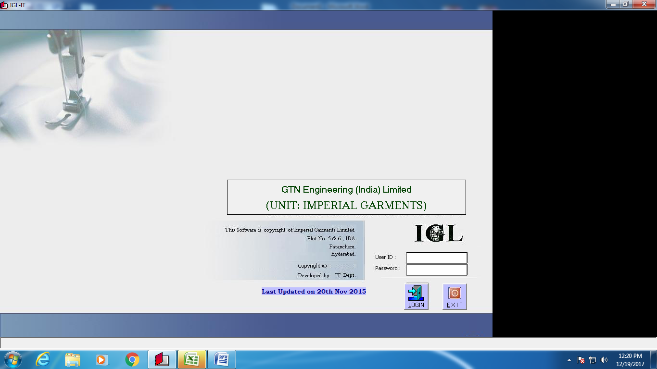

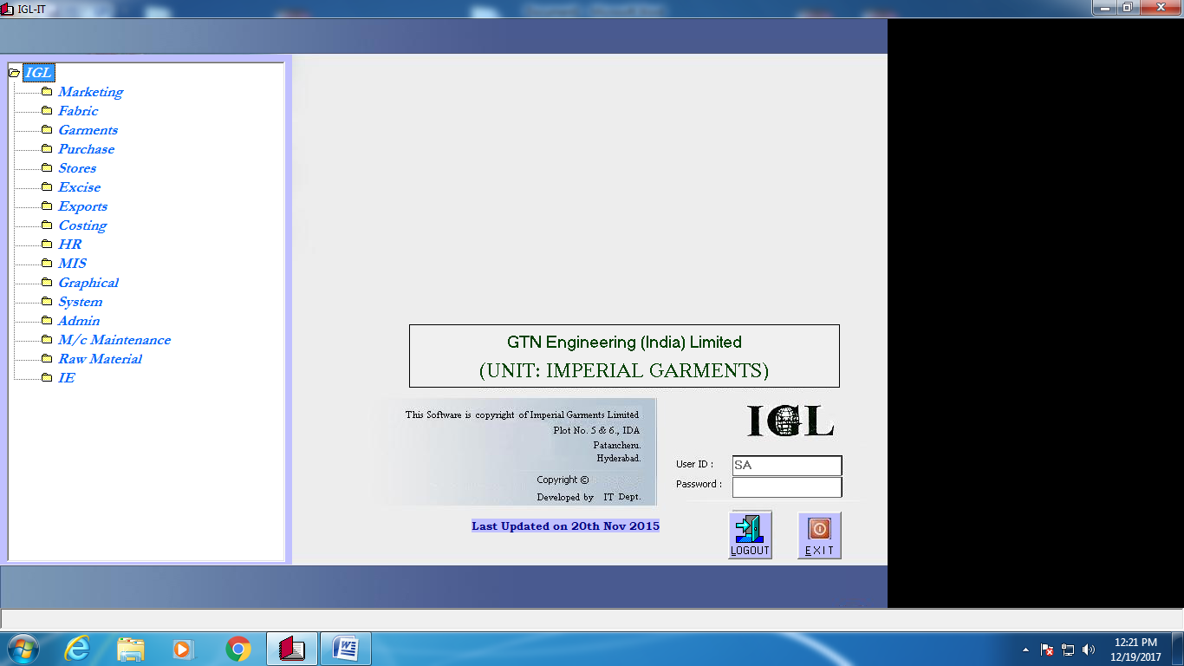

**Marketing**

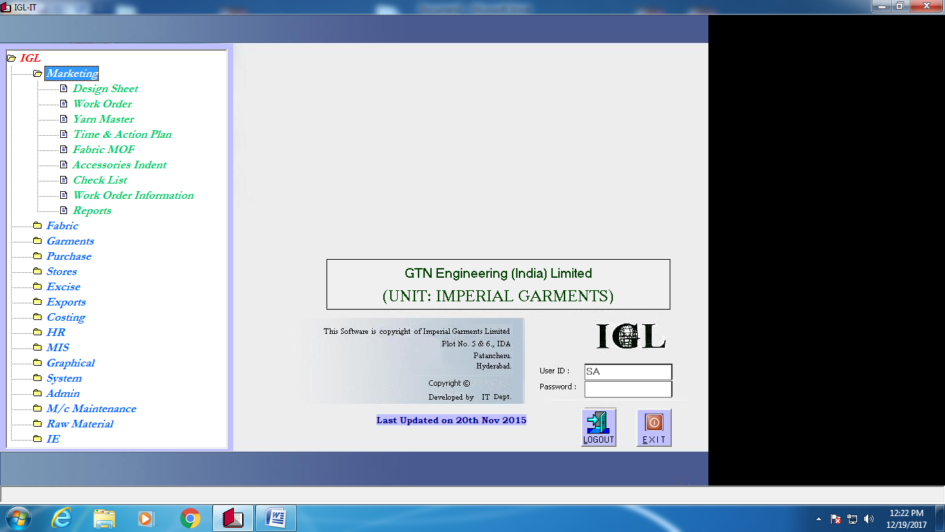

**Design sheet**

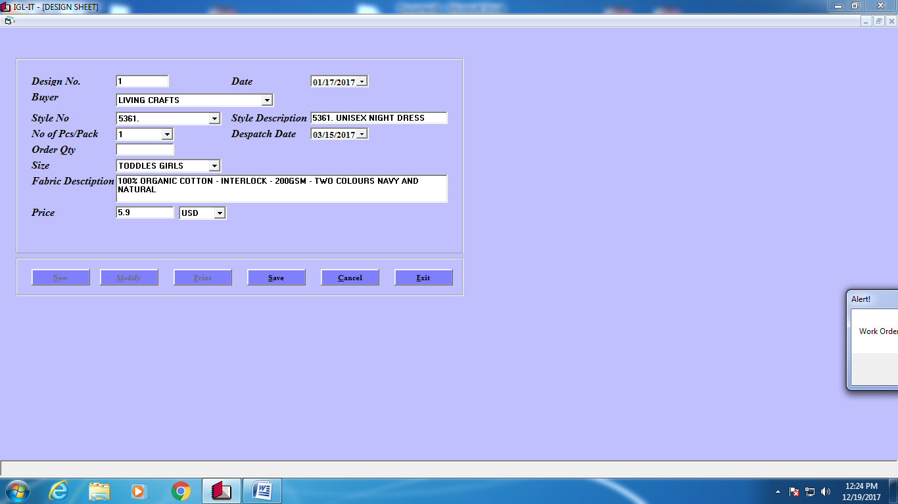

**Work Order**

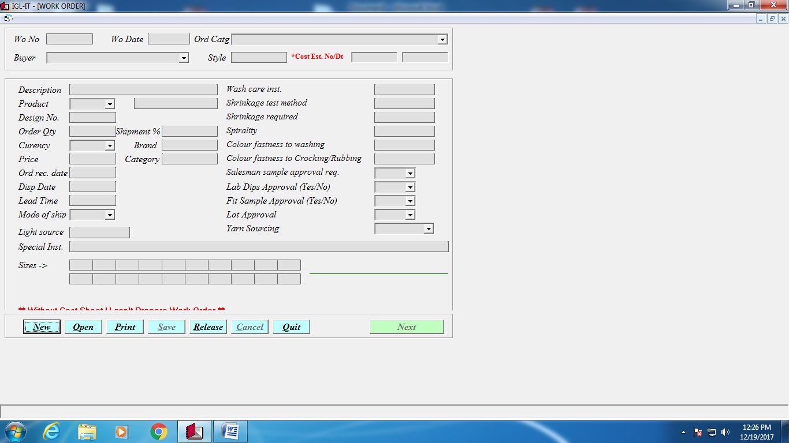

**YarnMaster**

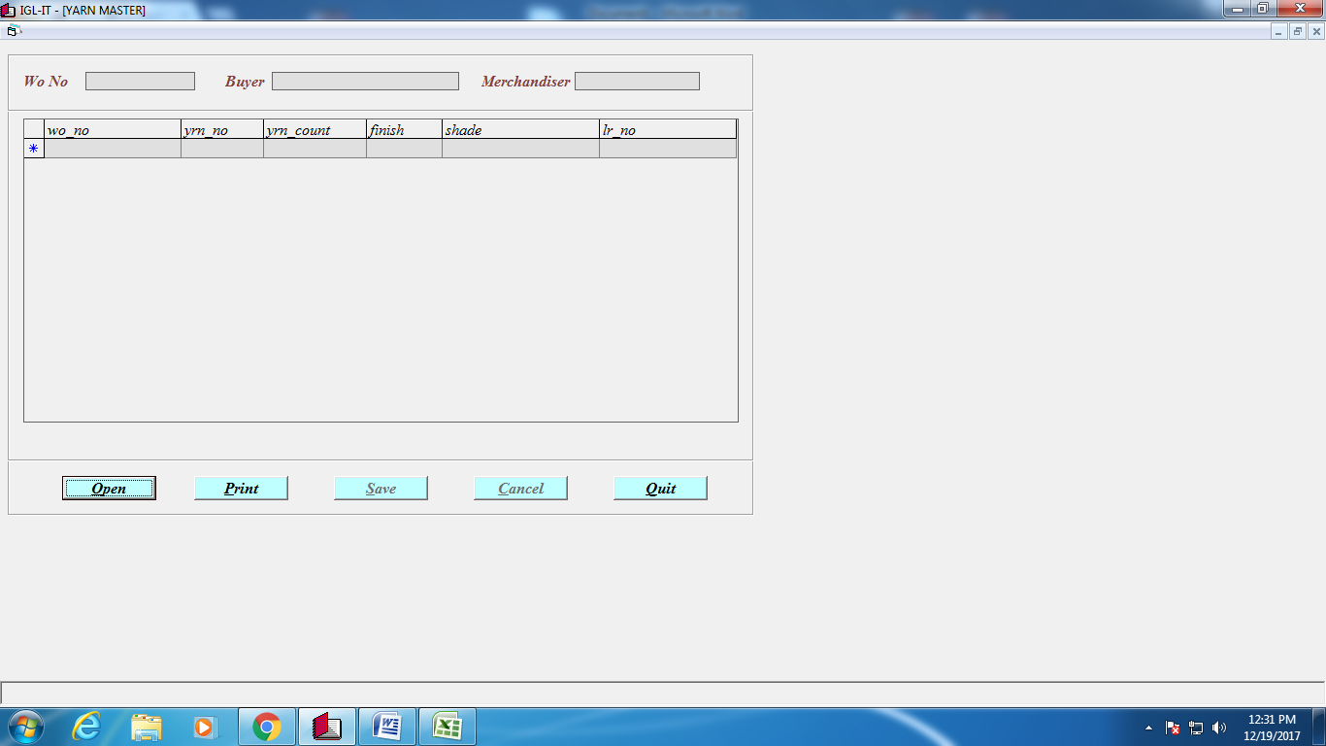

**MOF**

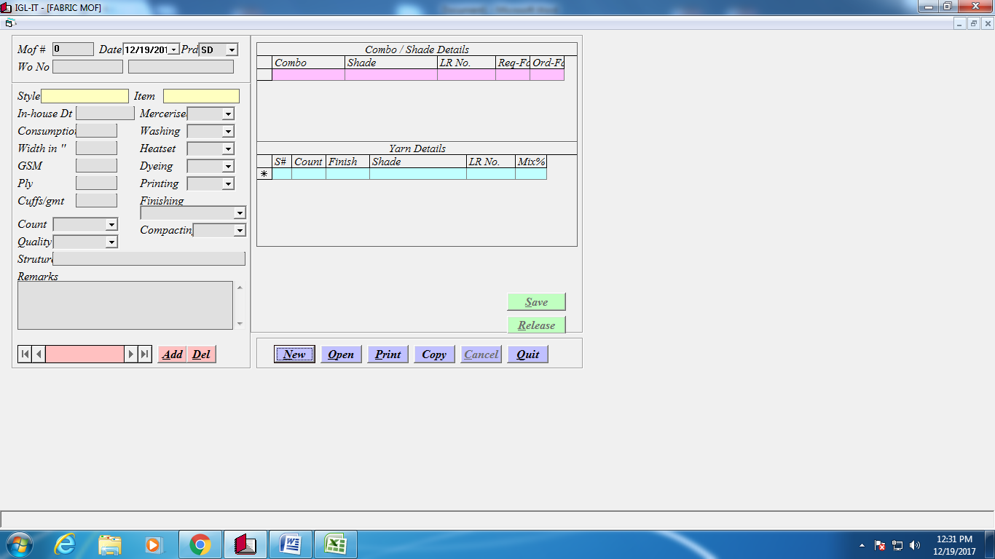

**Time & Action Plan**

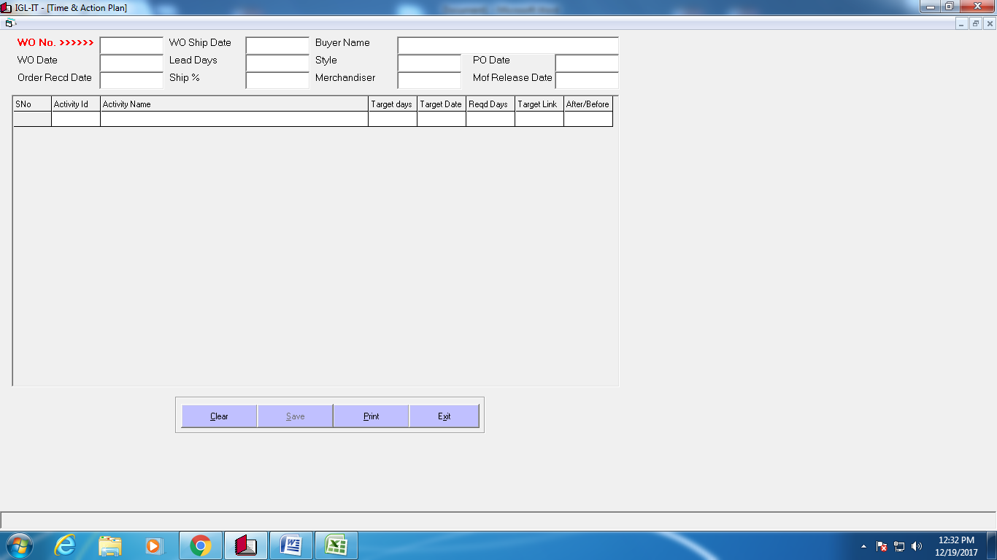

**Check List**

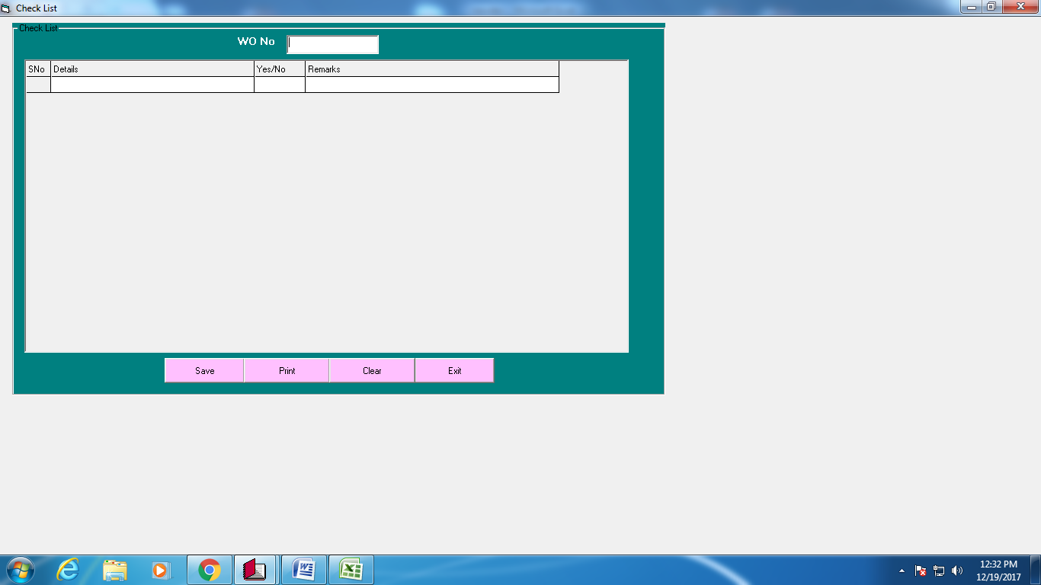

**Reports**

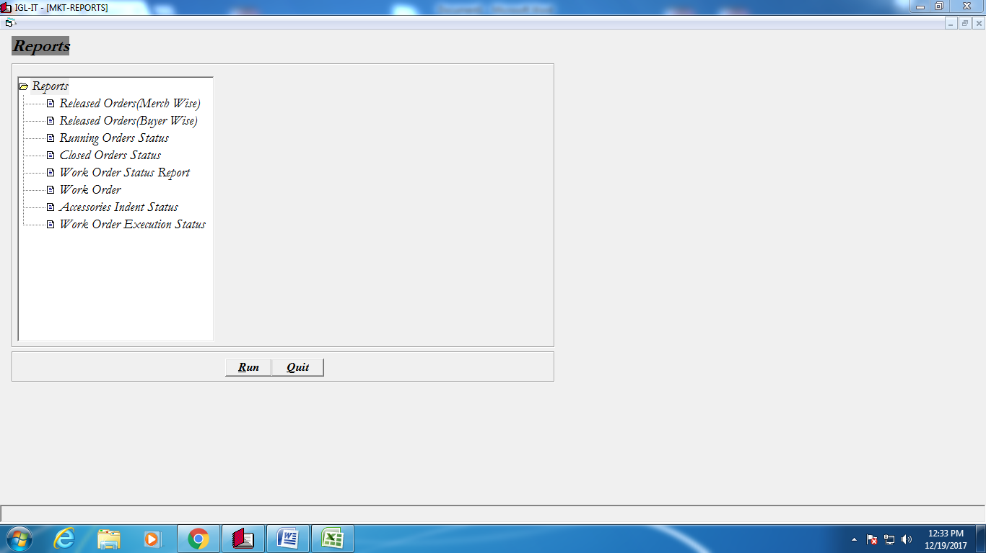

**Fabric Sourcing**

|  |
| --- |
| Yarn Requirement Calculation |
| Yarn Purchase PO |
| Yarn Process PO |
| Knittting PO |
| Process PO |
| Fabric PO |
| Yarn Jobwork DC |
| Yarn GRN (JOB/PUR) |
| Yarn WO-WO Transfer |
| Knitting DC |
| Knitting GRN |
| Knitting WO-WO Transfer |
| Fabric Process DC |
| Semi Fabric GRN |
| Fabric GRN |
| Fabric Rejection |
| Fabric WO-WO Transfer |
| Fabric Issue to Cutting |
| Fabric Gate Pass |
| Reports |
|  |

**Yarn Requirement Calculation**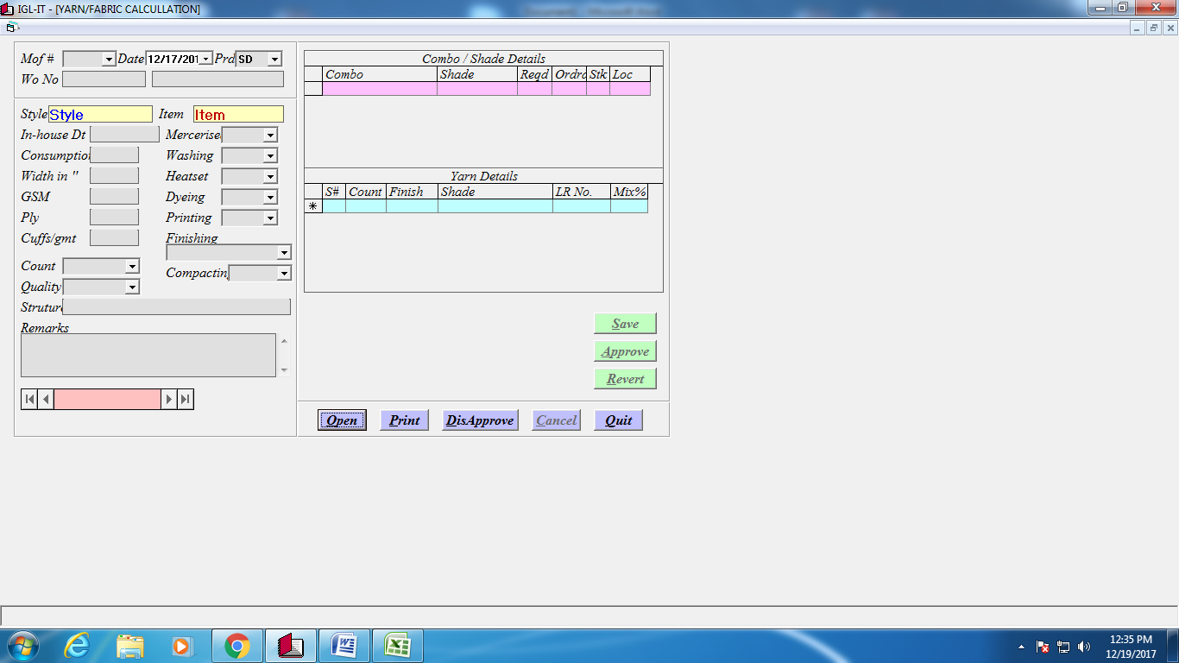

**LabdipEntry**

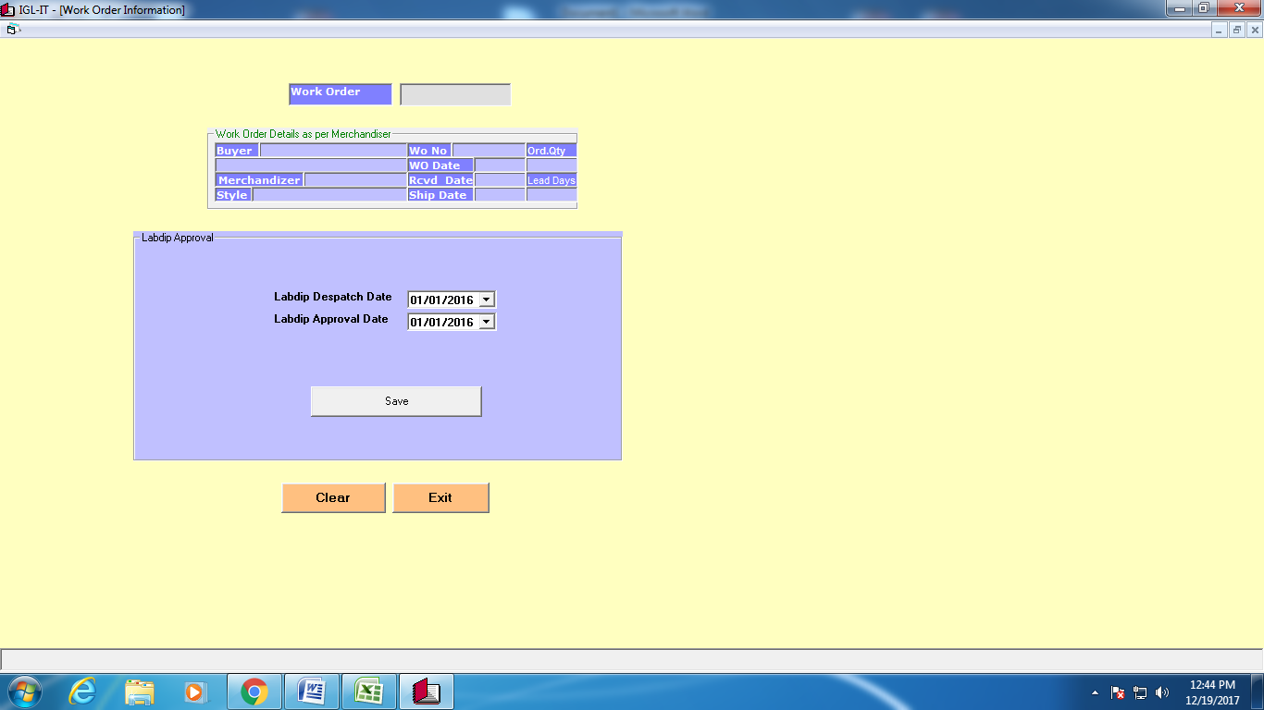

**Fabric Yarn Job Work DC**

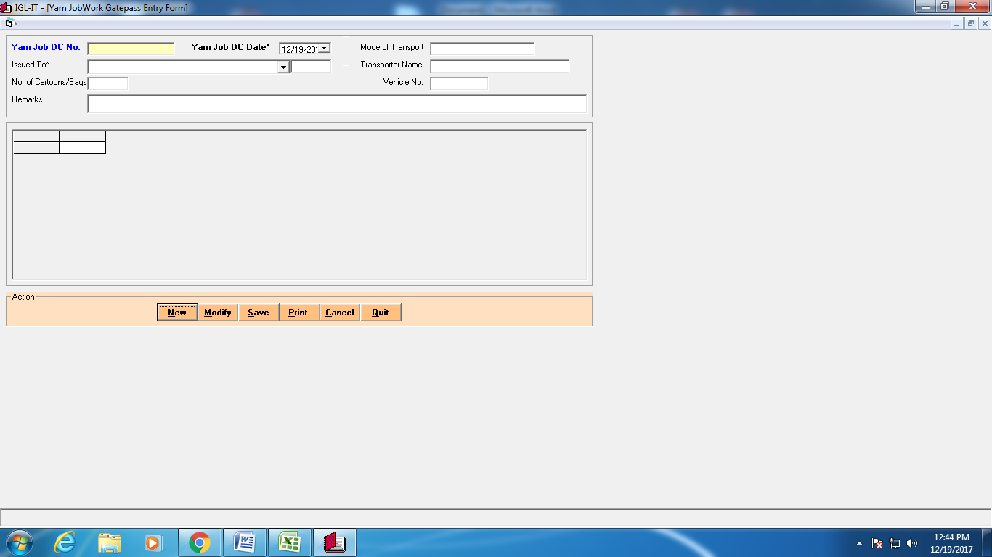

**Fabric Yarn Job Work GRN**

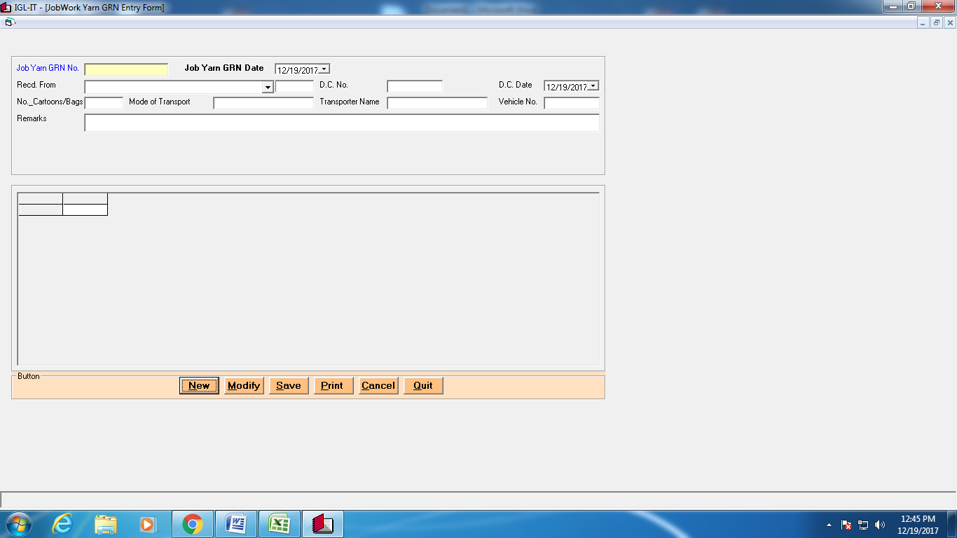

**Goods Receipt Note**

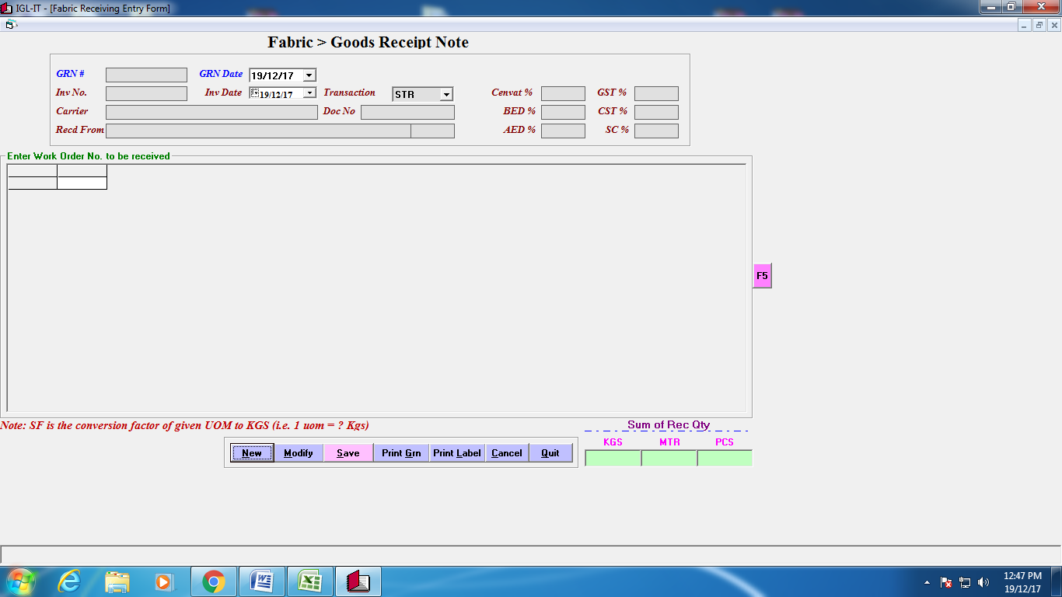

**Fabric checking**

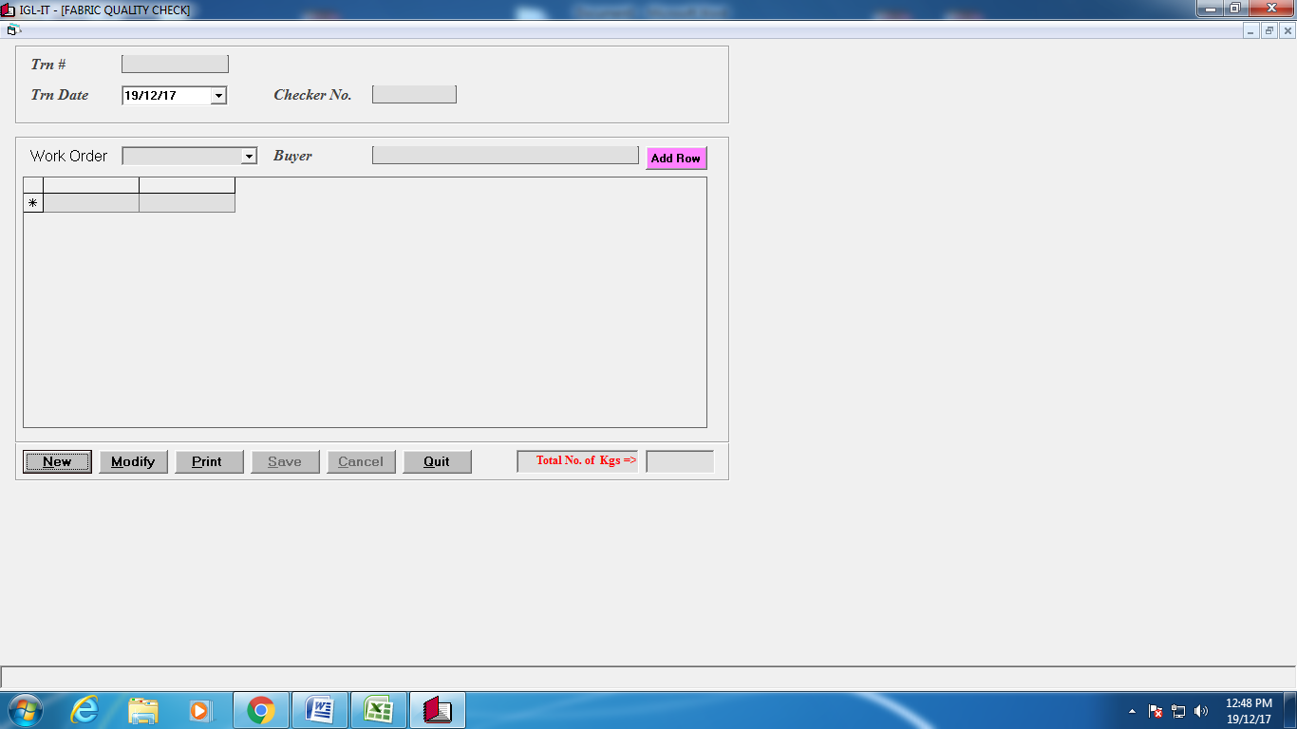

**Bulk Consumption**

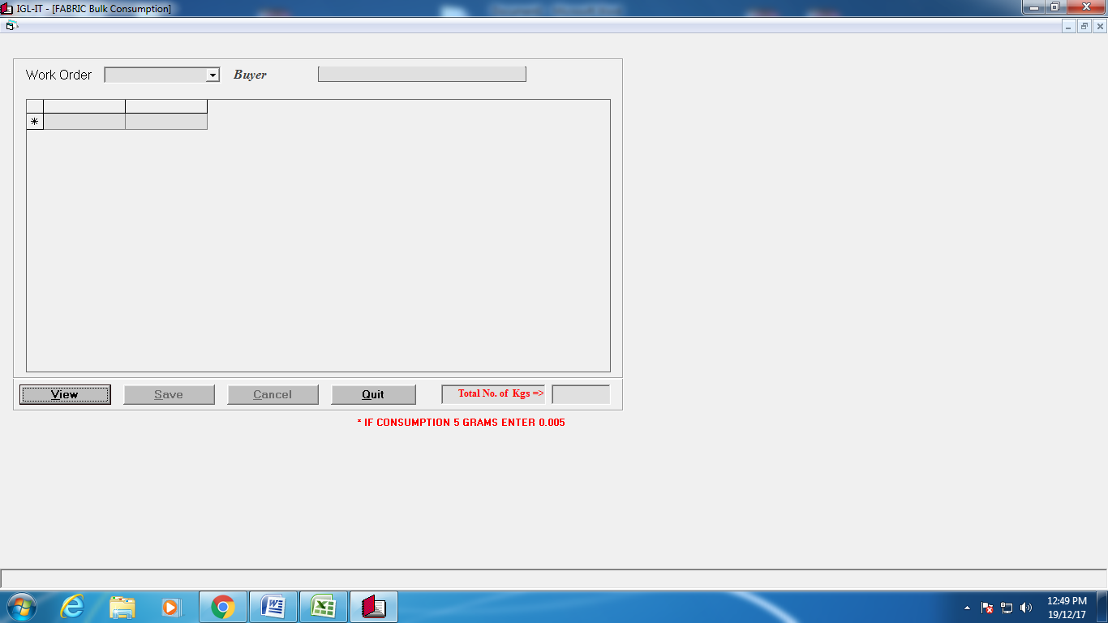

**Consumption Note**

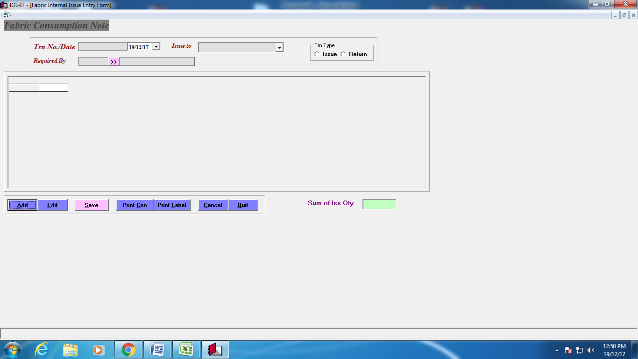

**GatePass**

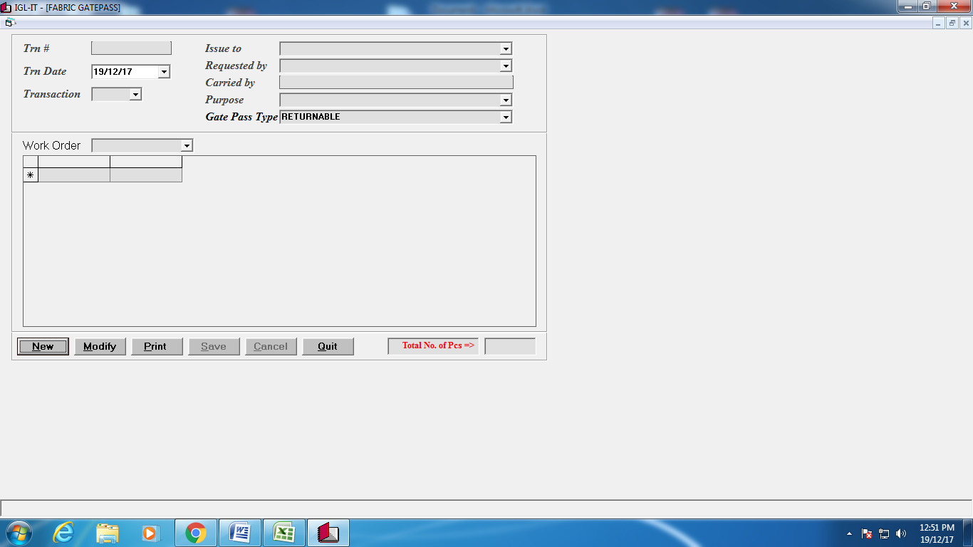

**Fabric Rejection**

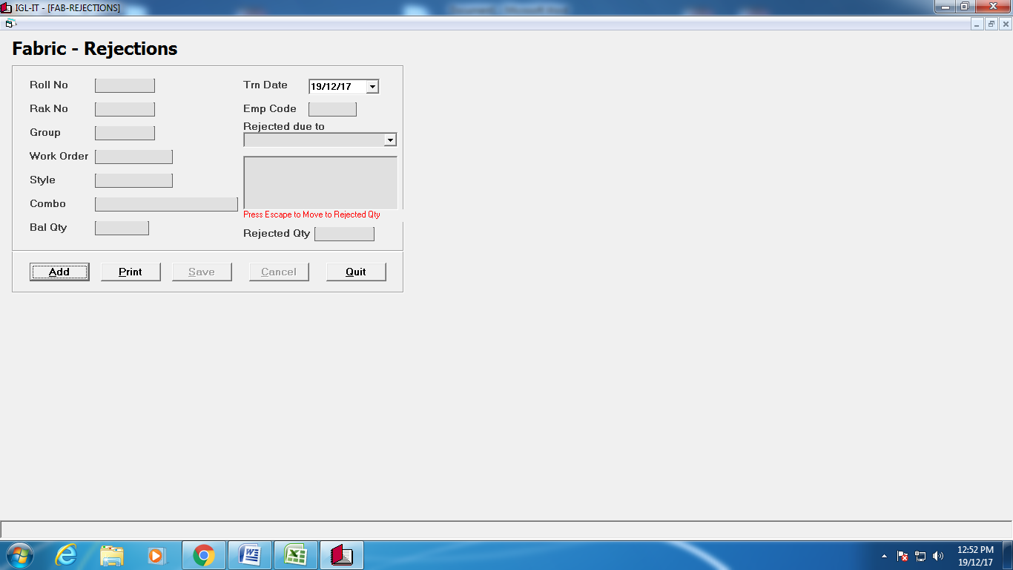

**Wo to Wo Transfer**

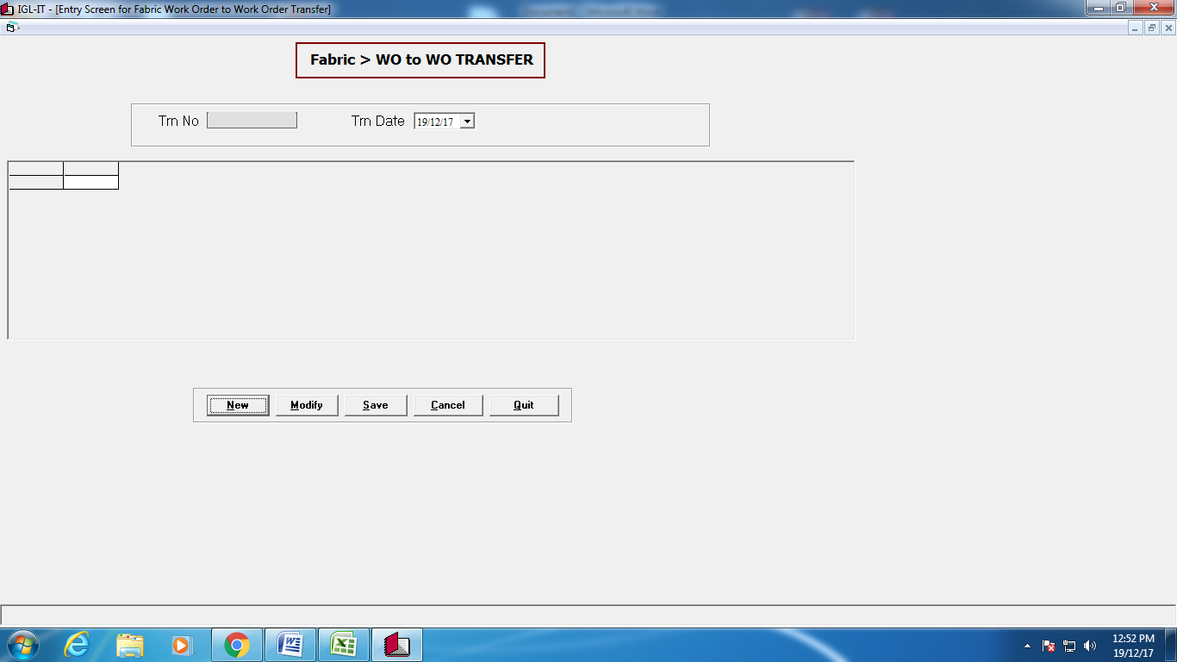

**Rak Updation**

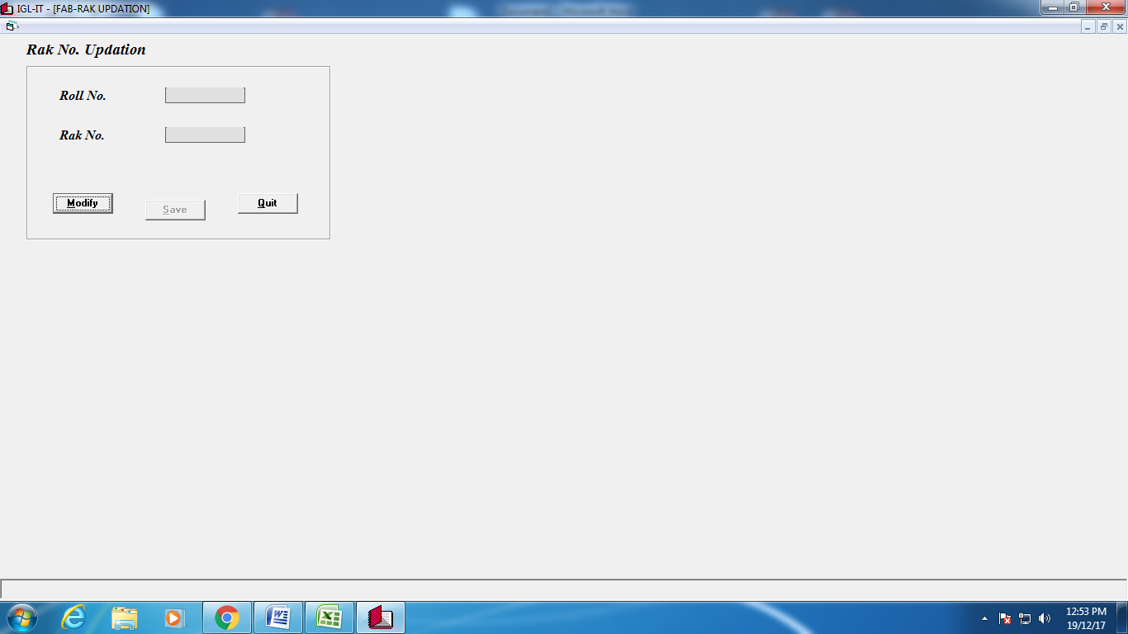

**Fabric Yarn PO**

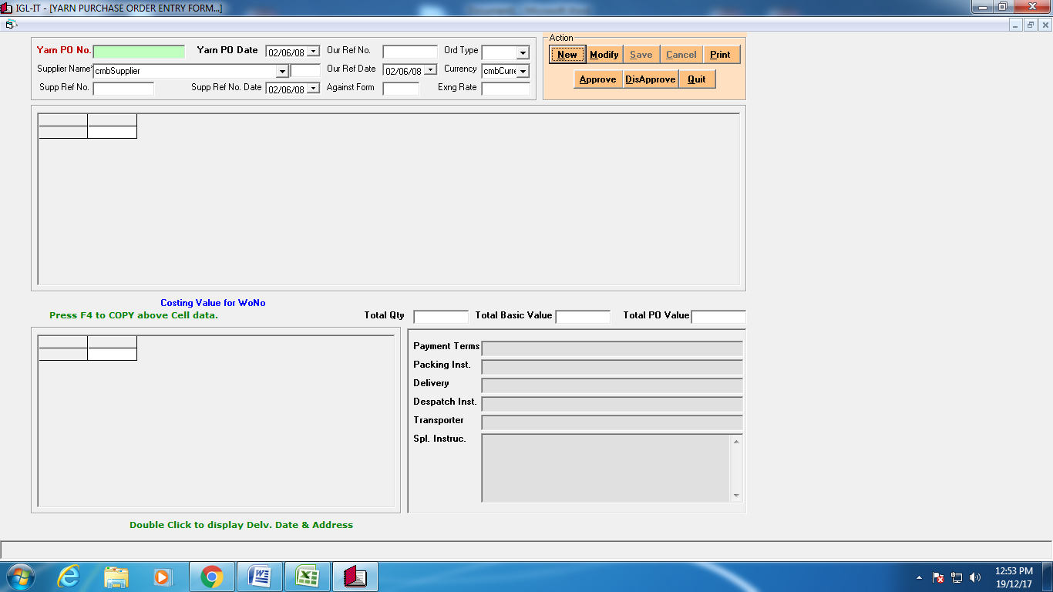

**Fabric Yarn GRN**

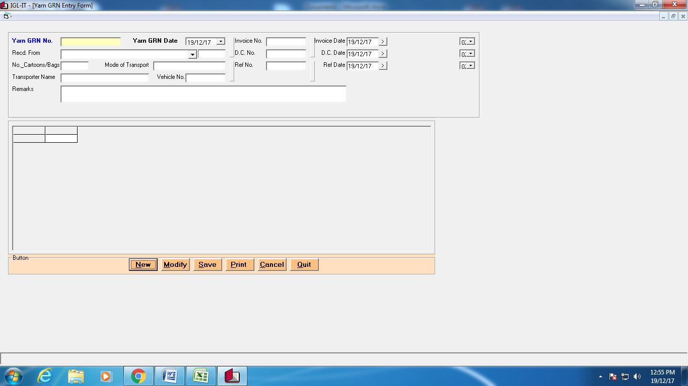

**Fabric Knit Order**

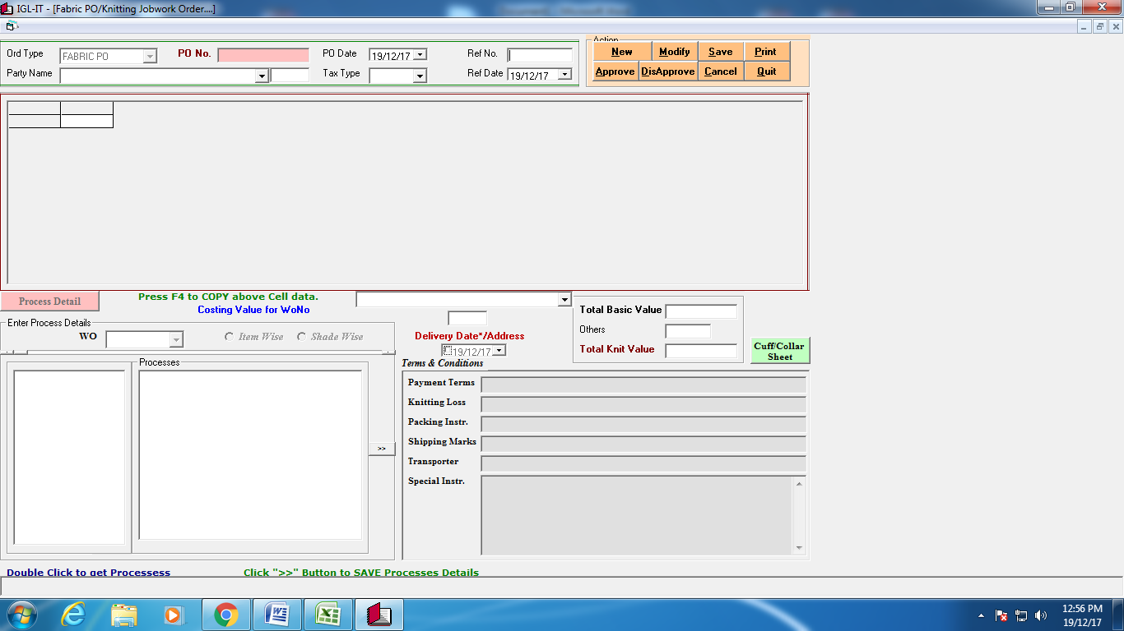

**Fabric Yarn DC**

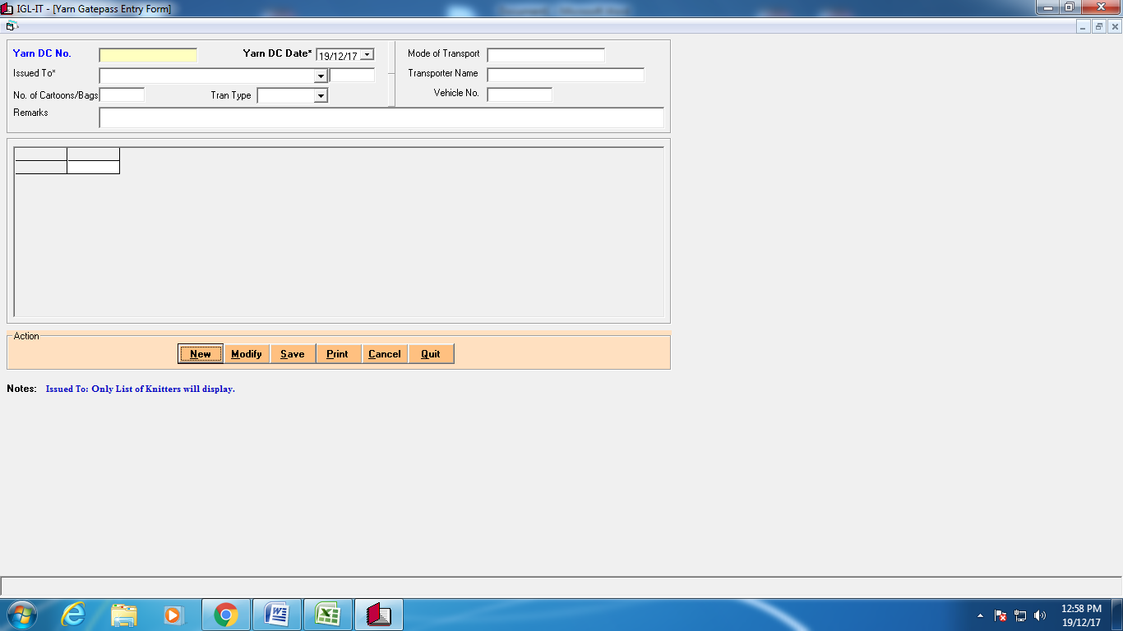

**Fabric knit GRN**

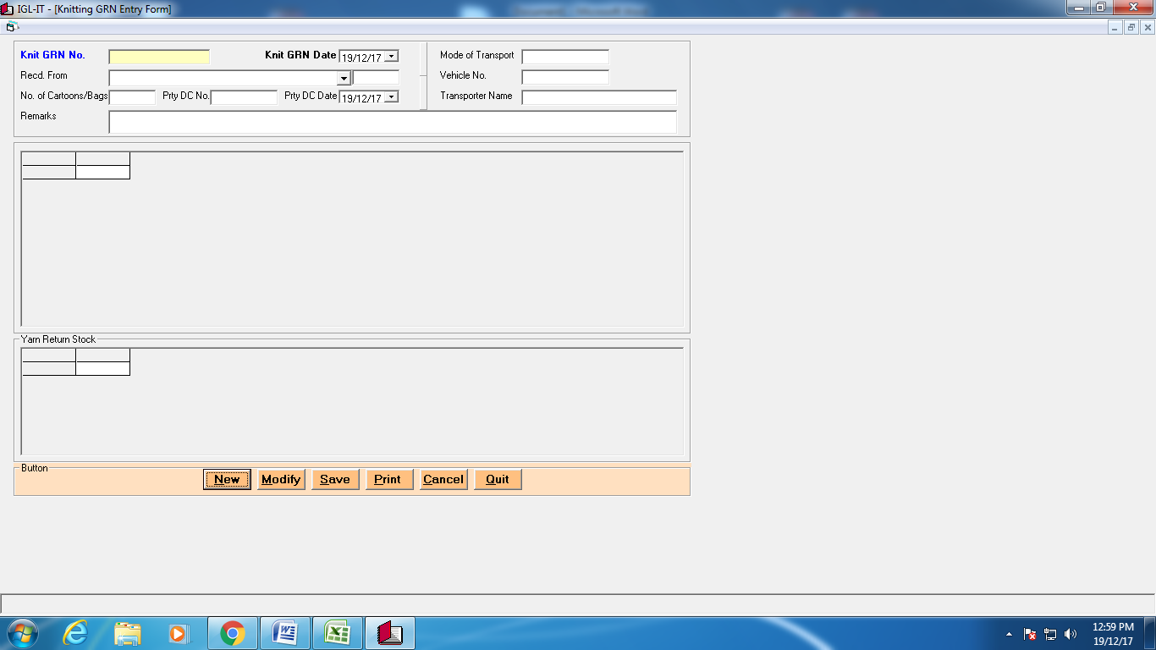

**Yarn WO to WO Transfer**

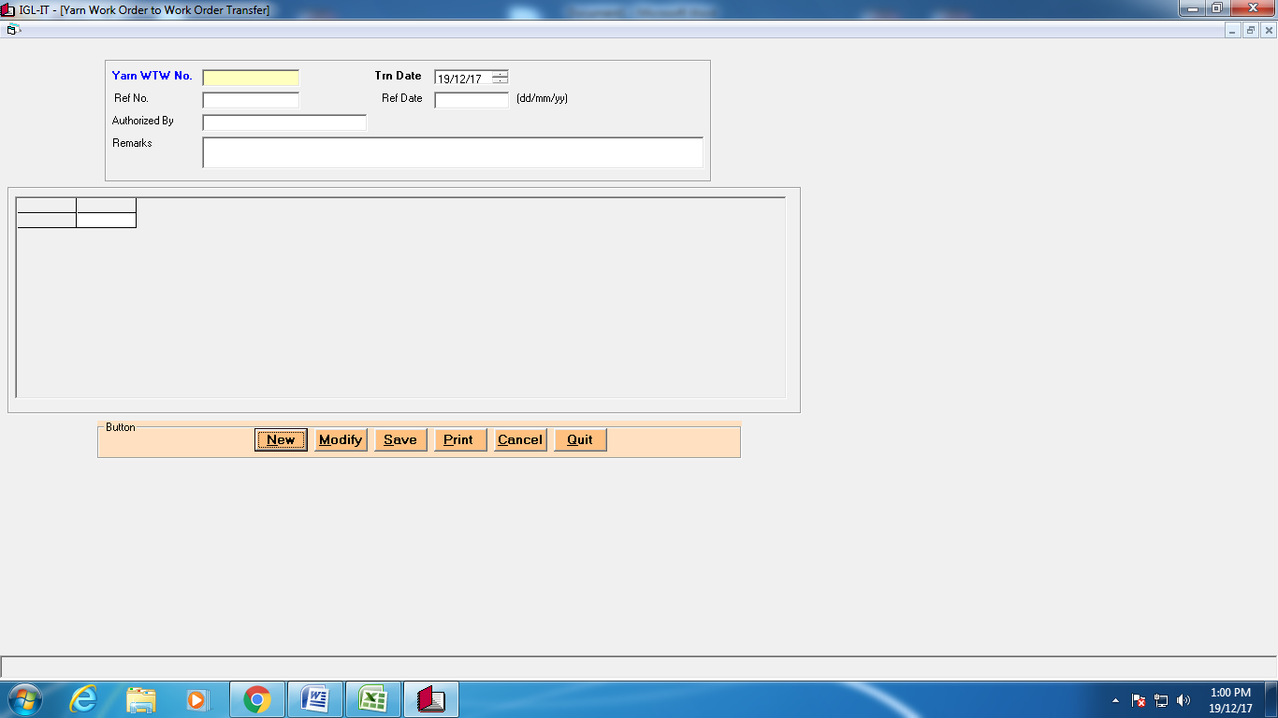

**Knnited fab WO to WO Transfer**

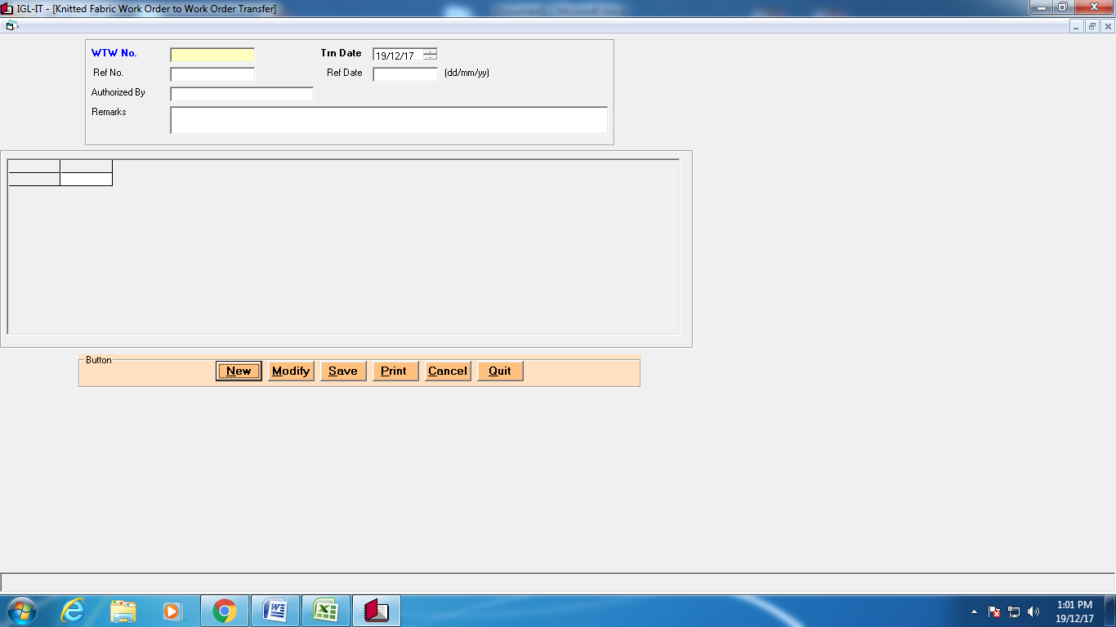

**Fabric Procc Job Order**

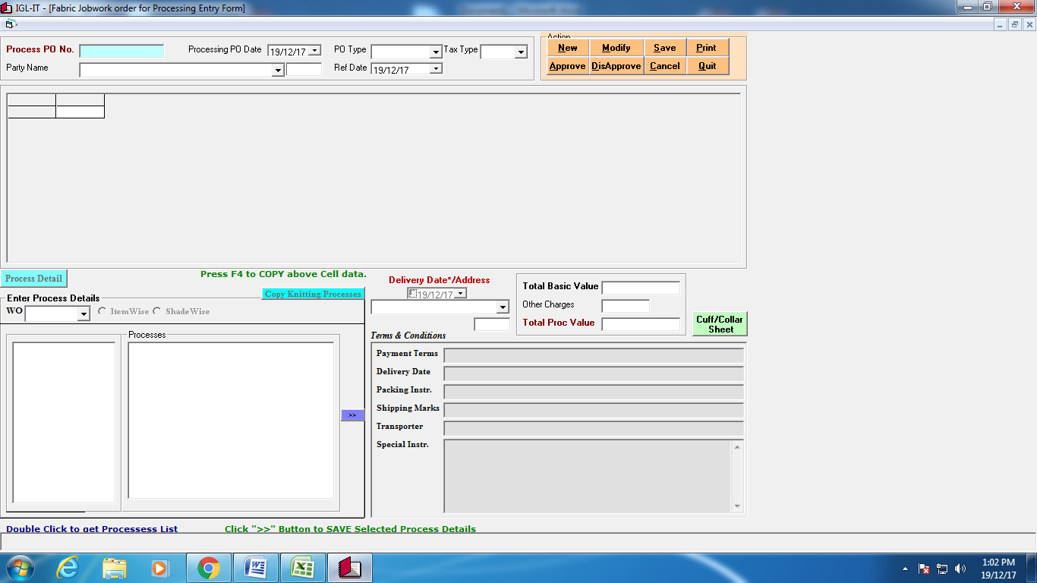

**Fabric Process DC**

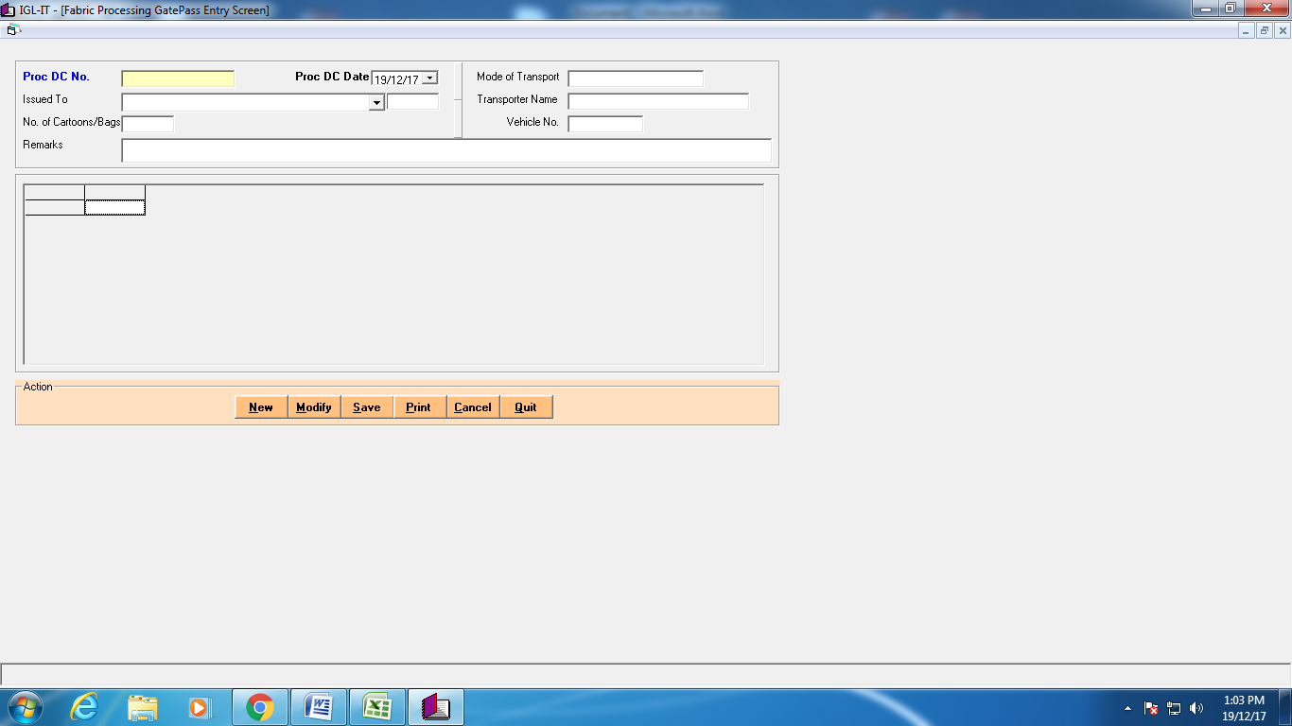

**Semi Fabric GRN**



**Fabric Satus Report**

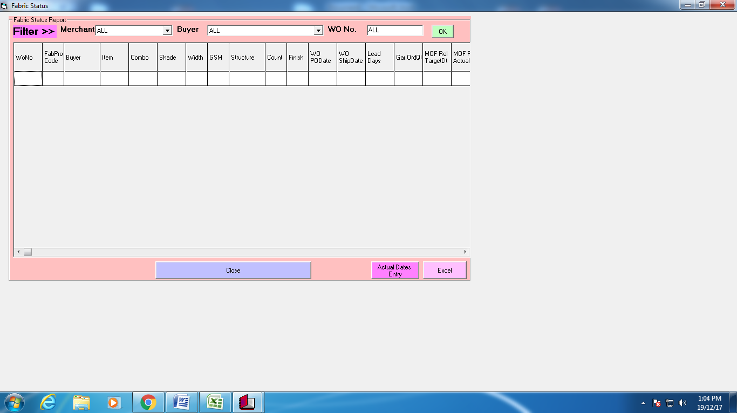

**Reports**

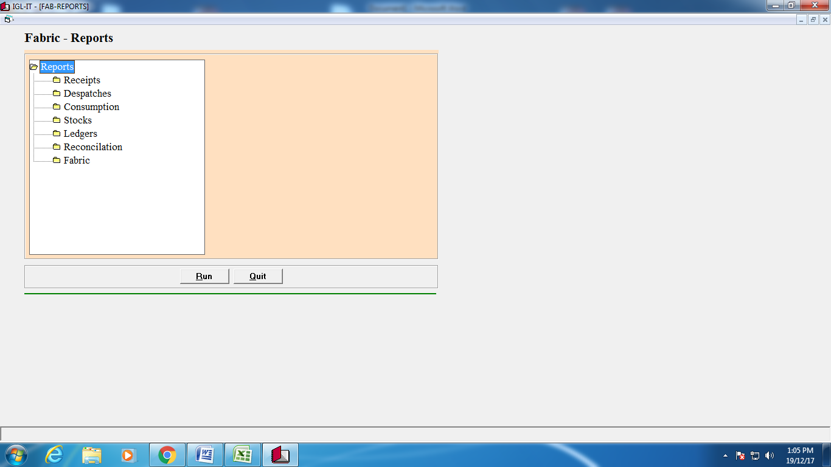

Garments

|  |
| --- |
| Cutting Panel Gate Pass |
| Cutting Panel GRN |
| Cutting Cunsomption |
| Cutting Production |
| Cutting Panel Rejection |
| Cut Garments Gate Pass |
| Cut Garments GRN |
| Cutting to Embroidary |
| Embroidary to Cutting |
| Cutting to Linein |
| Garments Check out |
| Garments Rejections |
| Garments Ironing |
| Garments Packing |
| Garments Jobwork PO |
| Garments Jobwork DC |
| Garments Jobwork GRN |
| Garments DC (Sale/Trf/Job) |
| Garnents GRN (Trf/Job) |
| Move Leftover Garments to Stock |
| Reports |
|  |
|  |

**Cutting Panel Gate Pass**

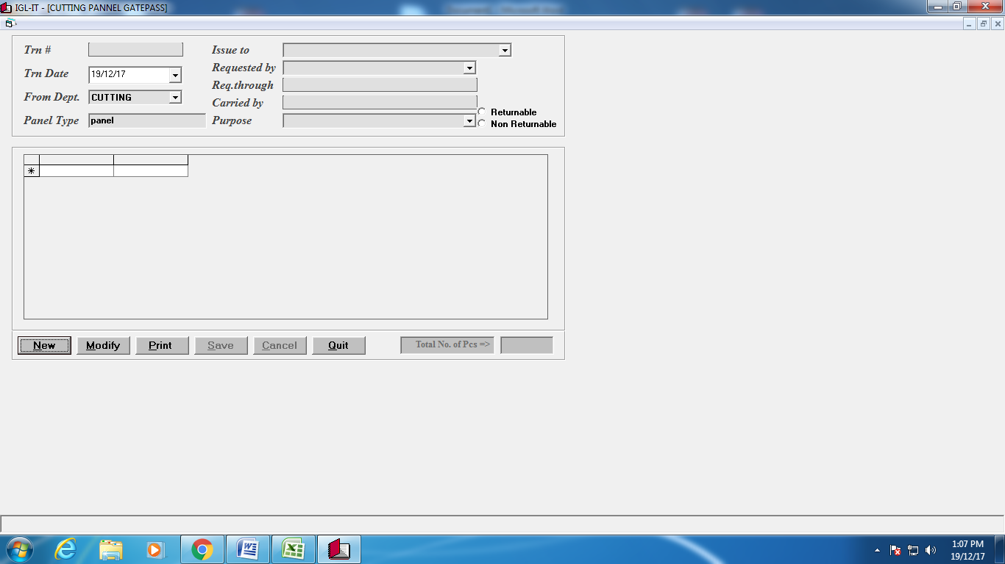

**Cutting Panel GRN**

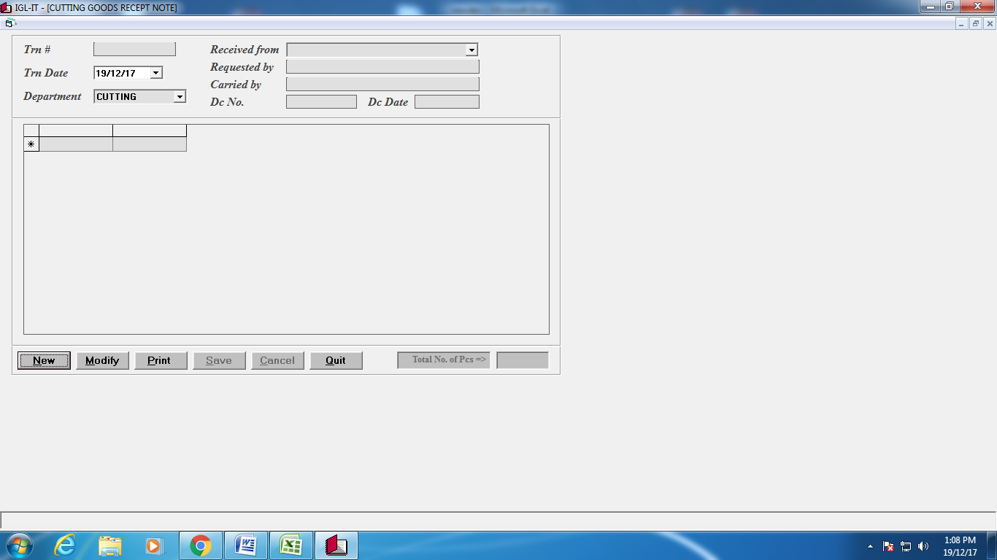

**Cutting Cunsomption** 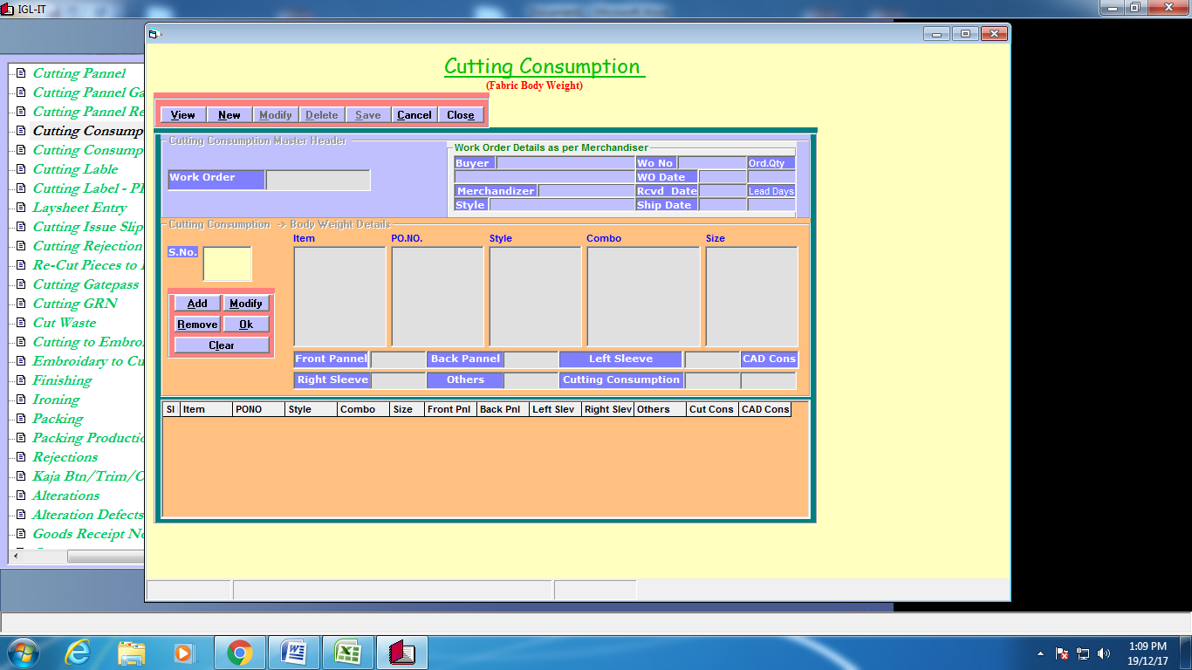

**Cutting Production**

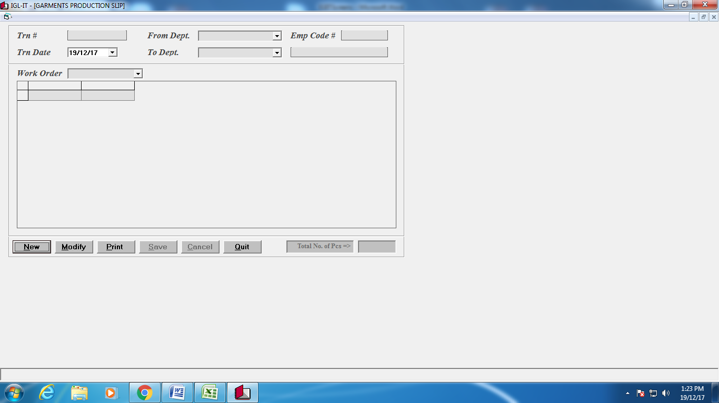

**Garments Ironing**

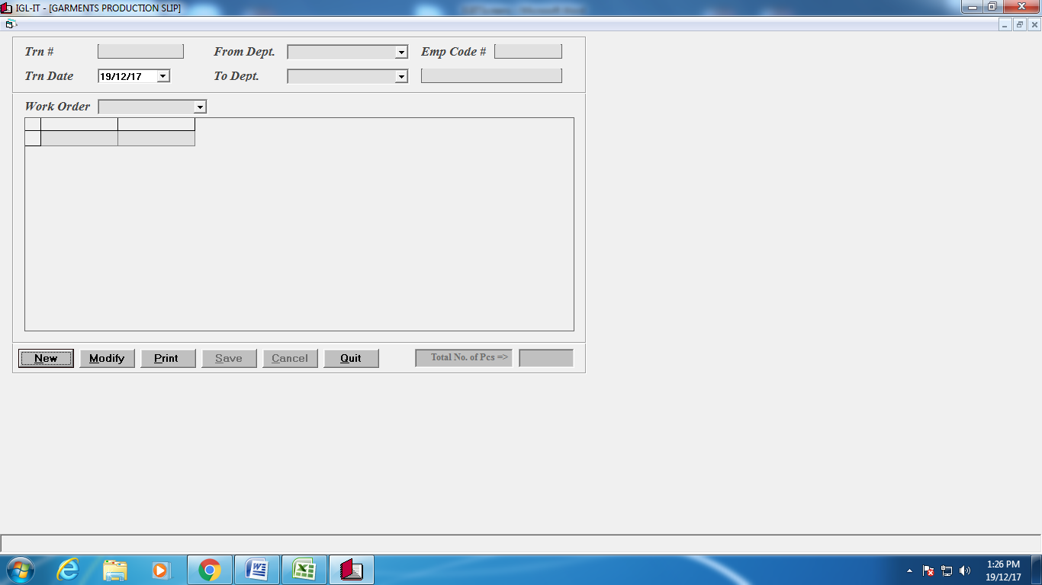

**Garments Packing**



**Cut Garments Gate Pass** 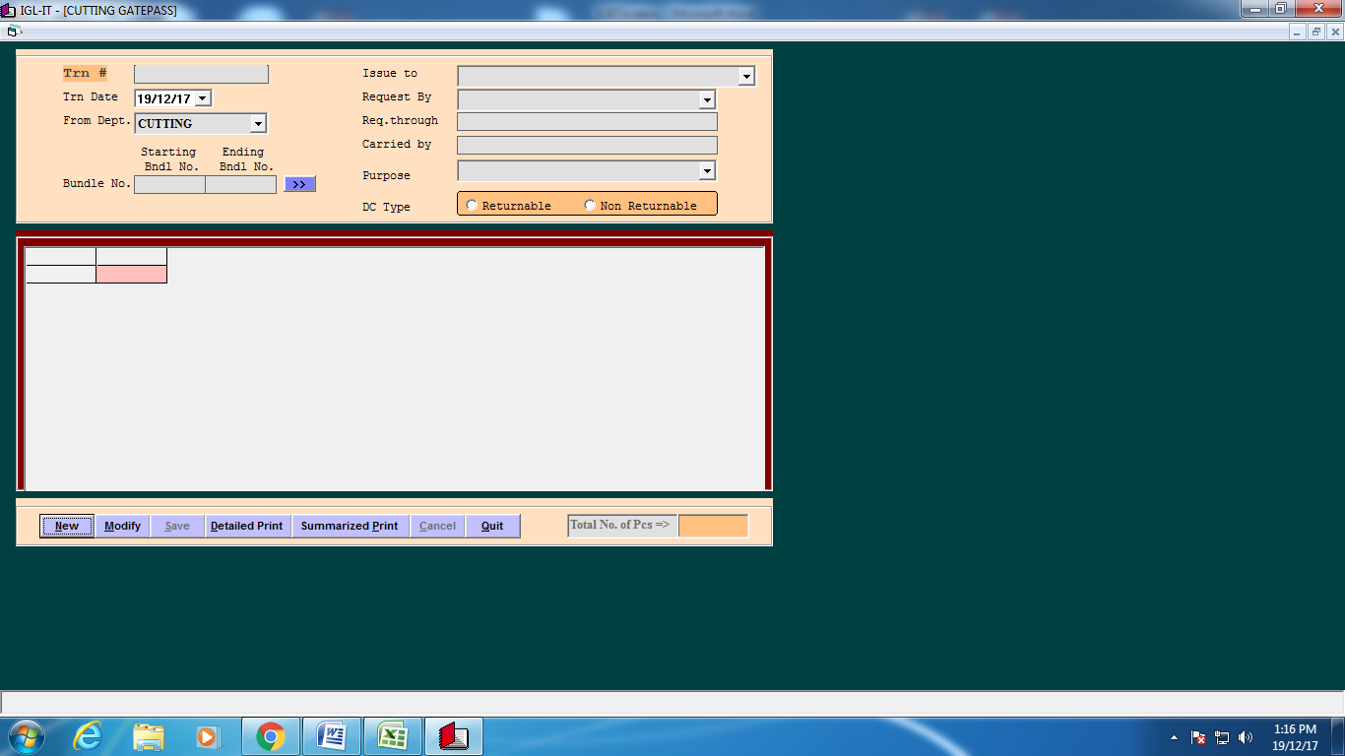

**Cut Garments GRN** 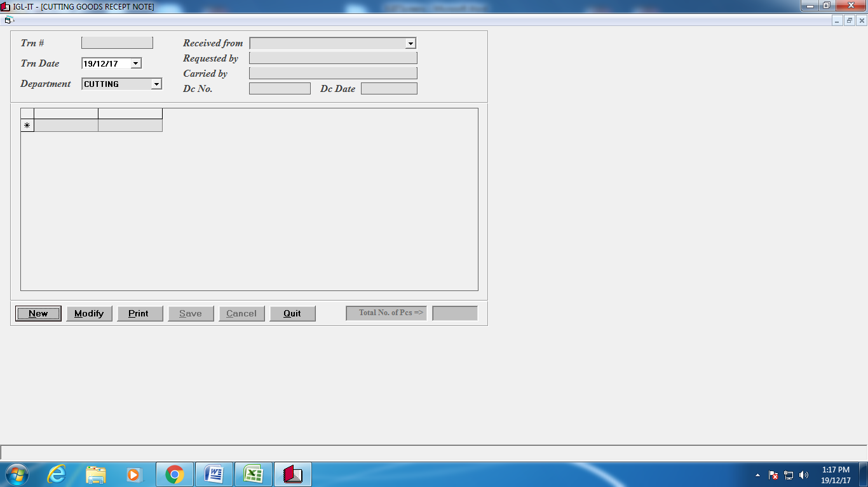

**Cutting to Embroidary** 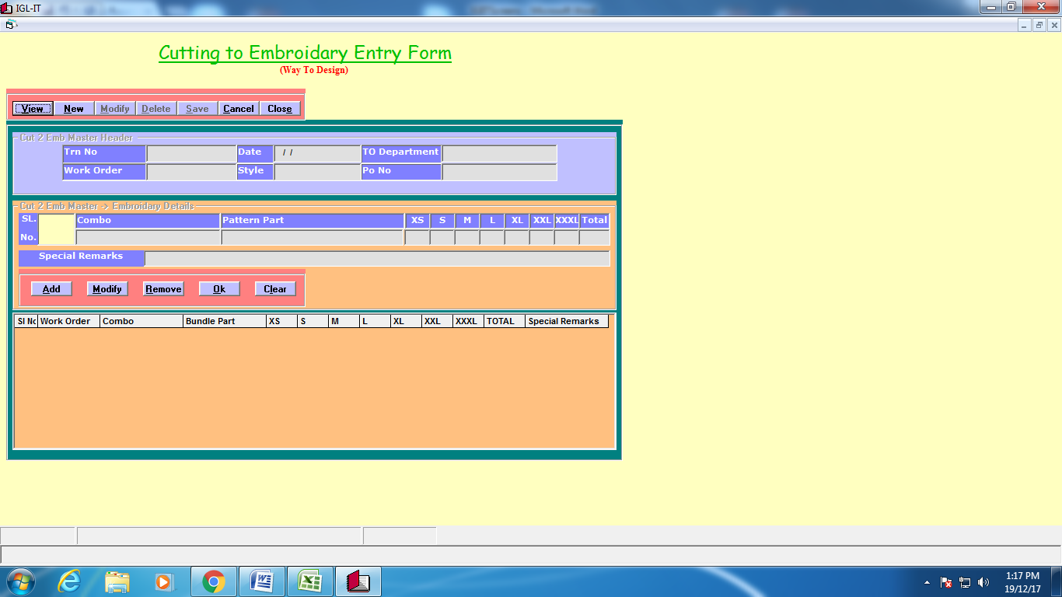

**Embroidary to Cutting** 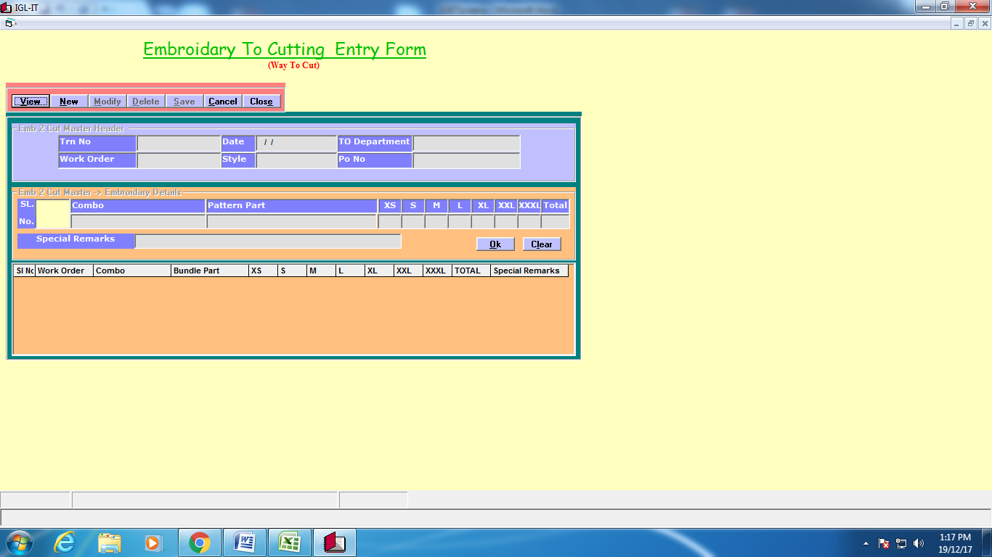

**Cutting to Line input**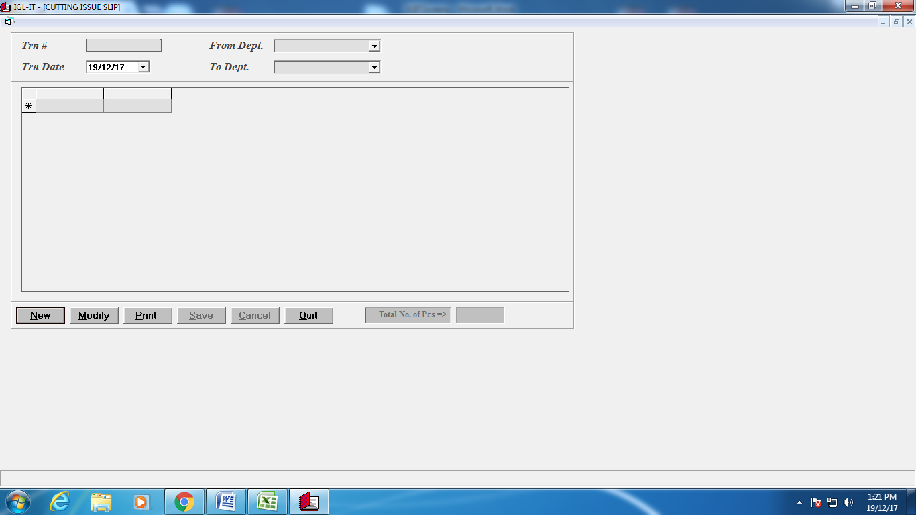

**Garments Jobwork DC** 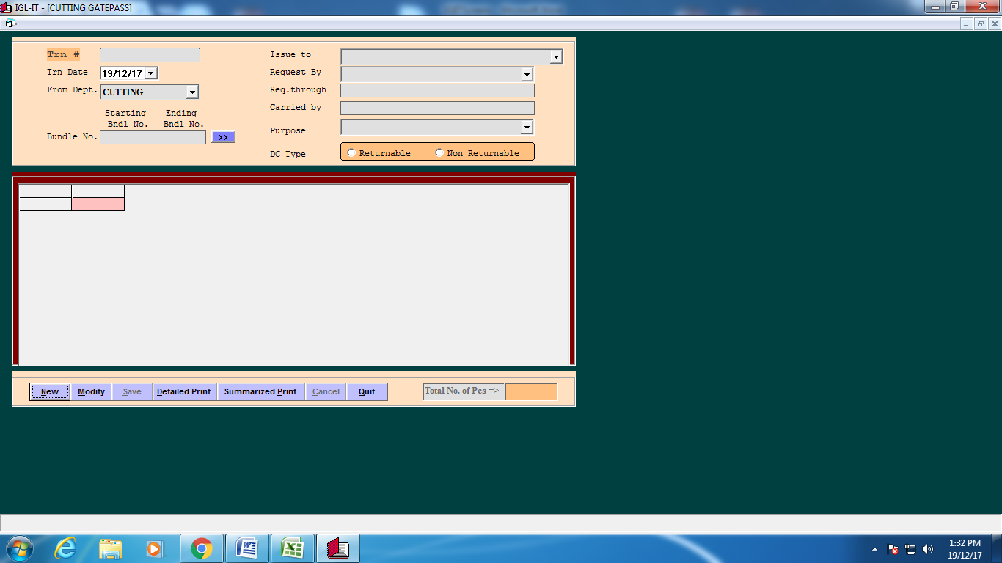

**Garments Jobwork GRN**

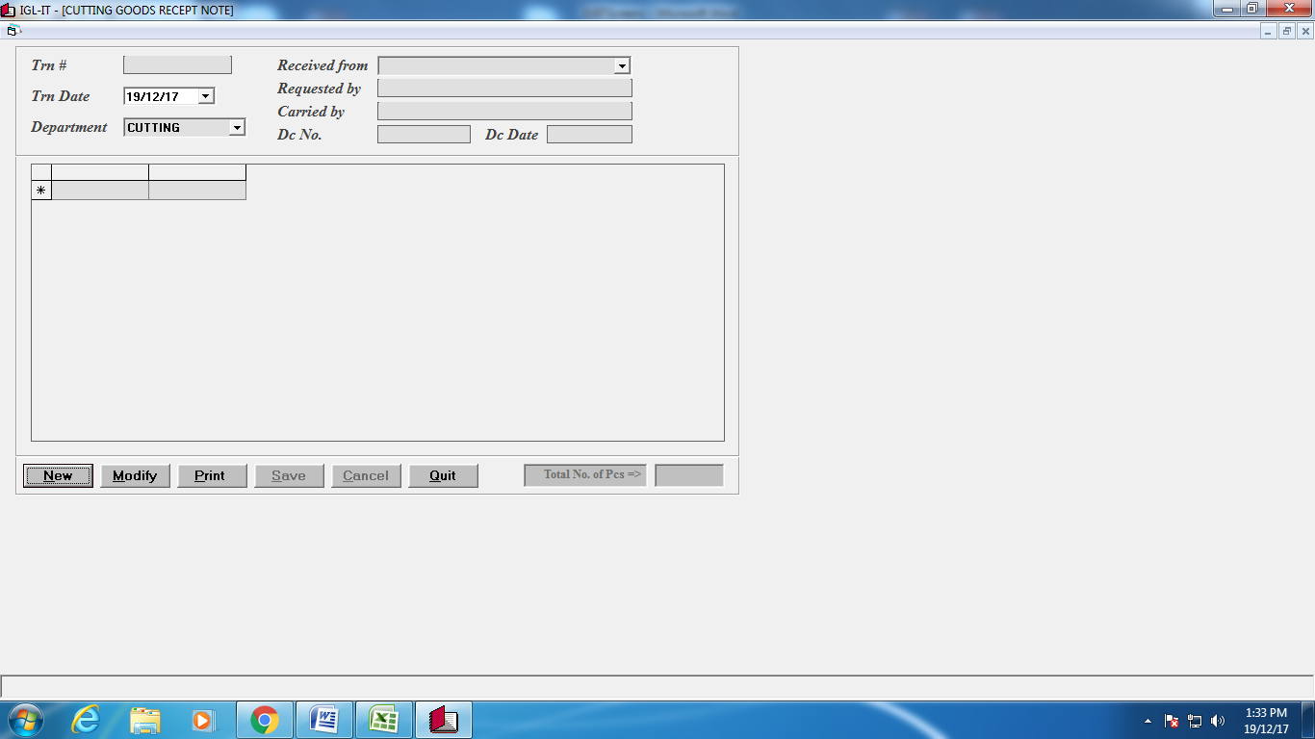

**Garments DC (Sale/Trf/Job)**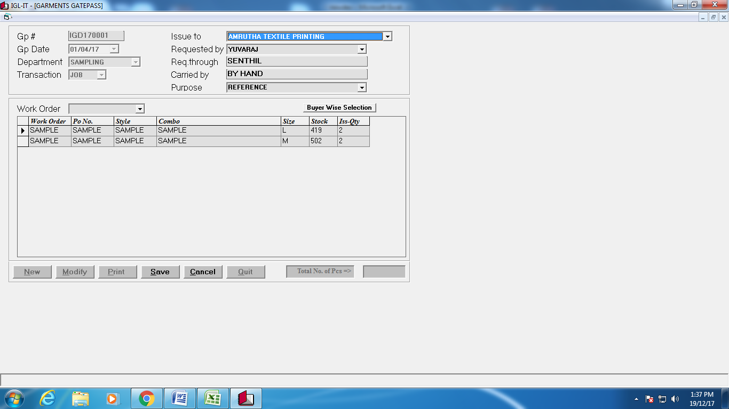

**Garnents GRN (Trf/Job)**

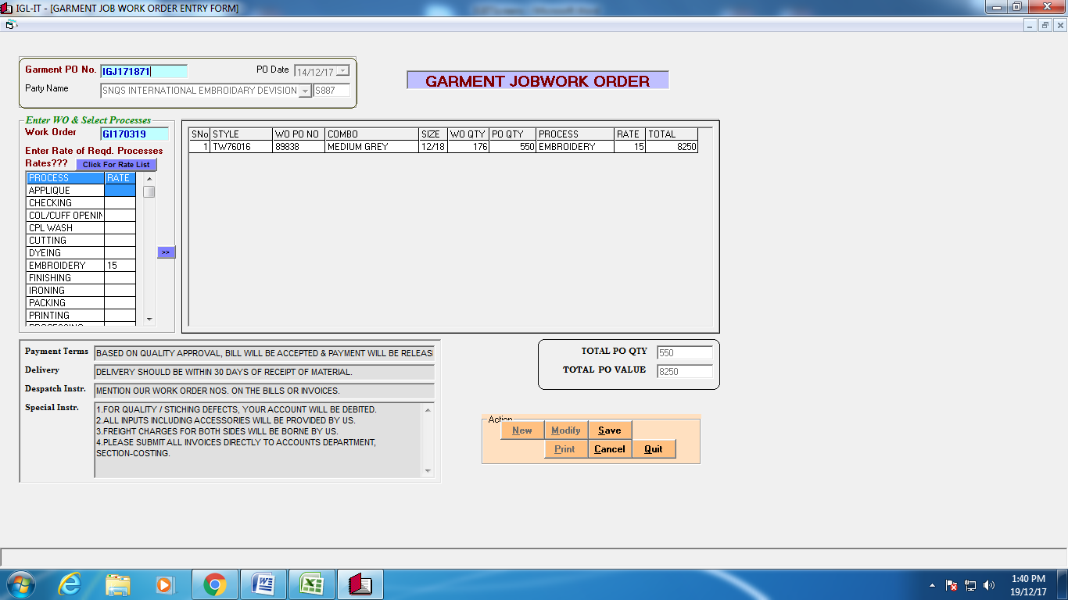

**Move Leftover Garments to Stock**

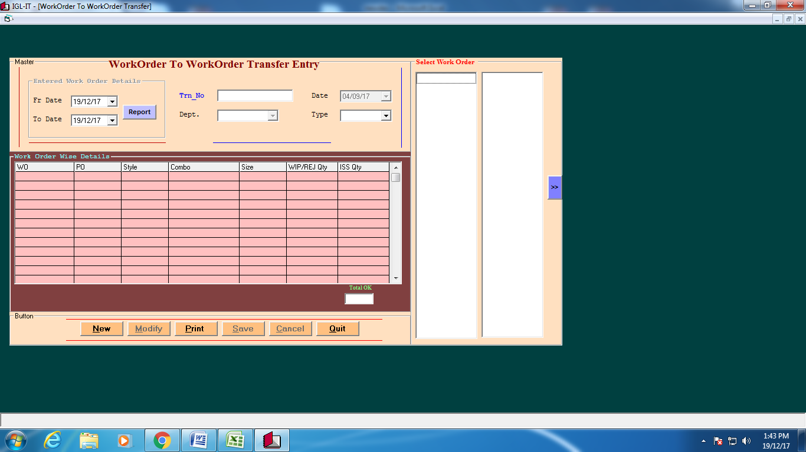

**Reports** 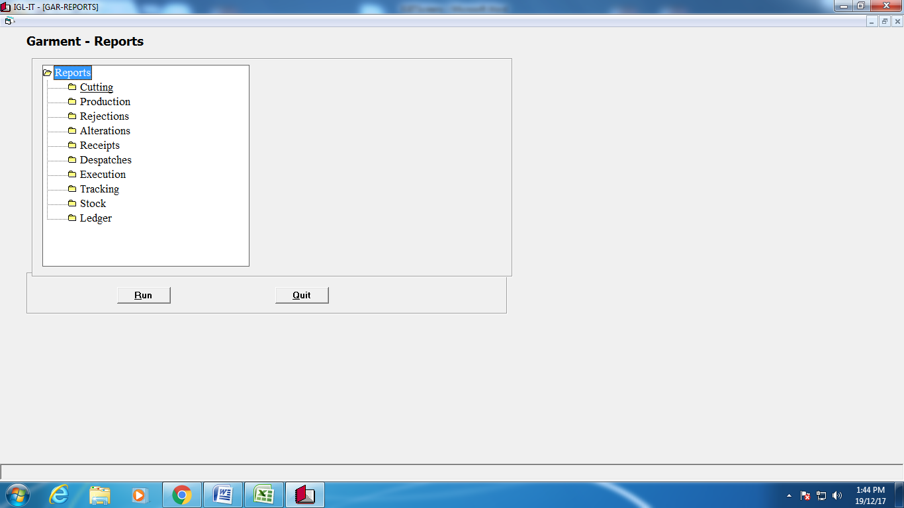

**Trims Stores**

**Party master** 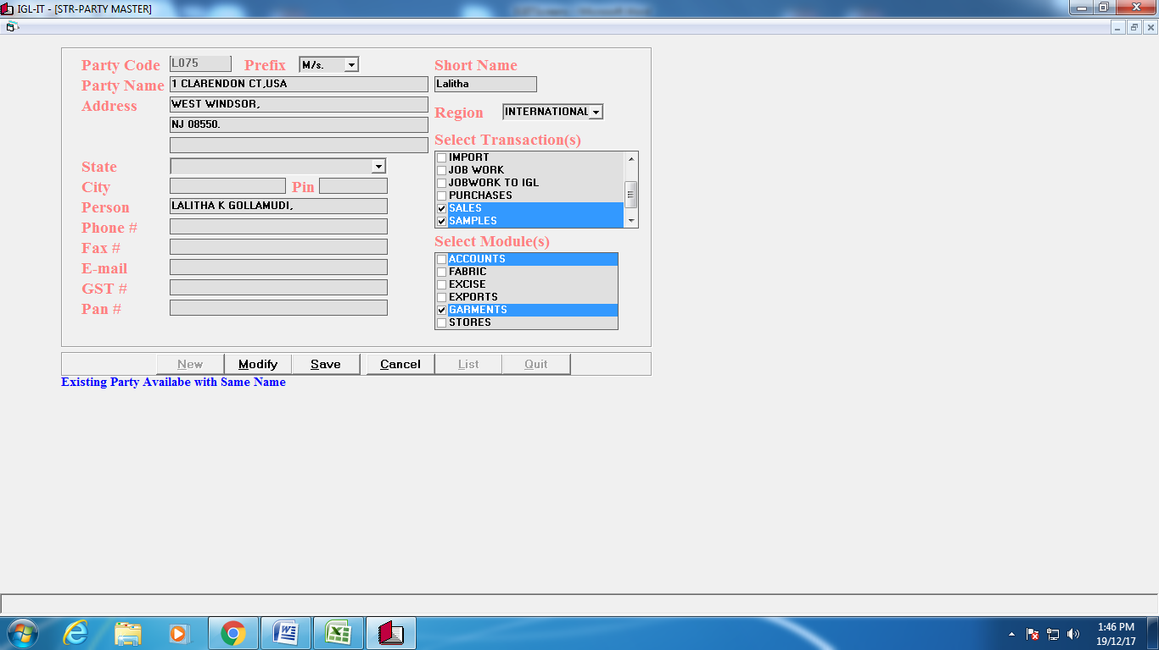

**Items Master**

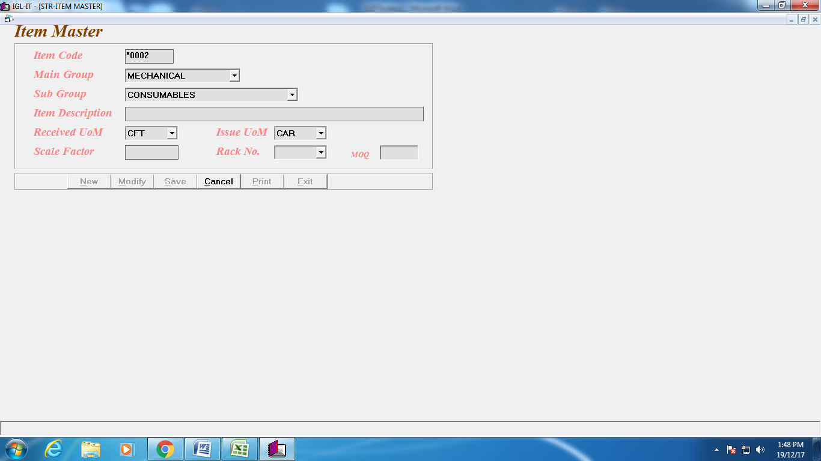

**Trims PO**

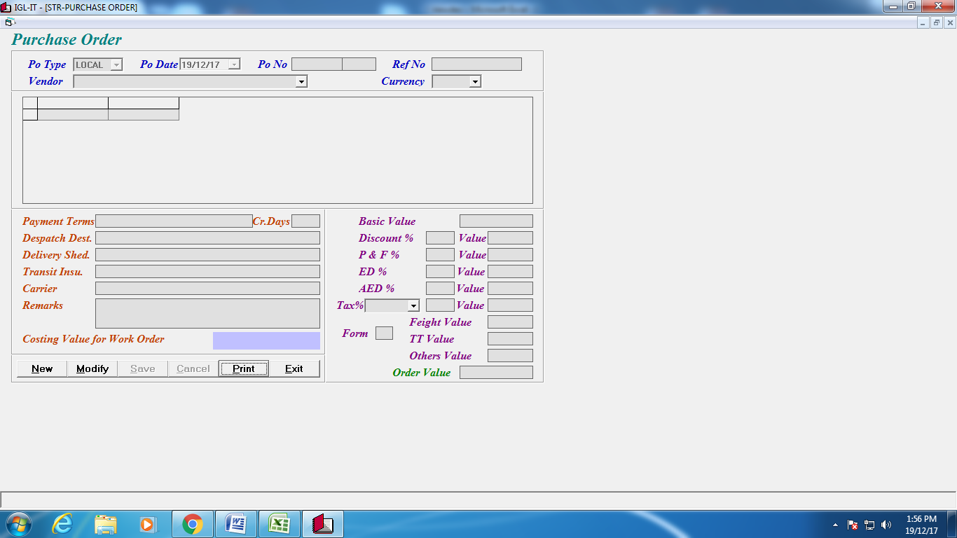

**Trims GRN**

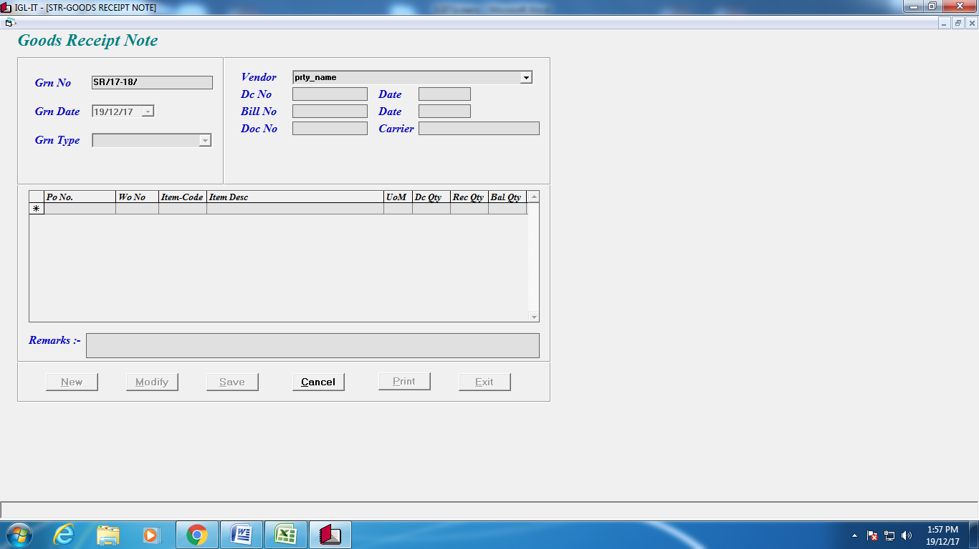

**Trims Issue to Production**

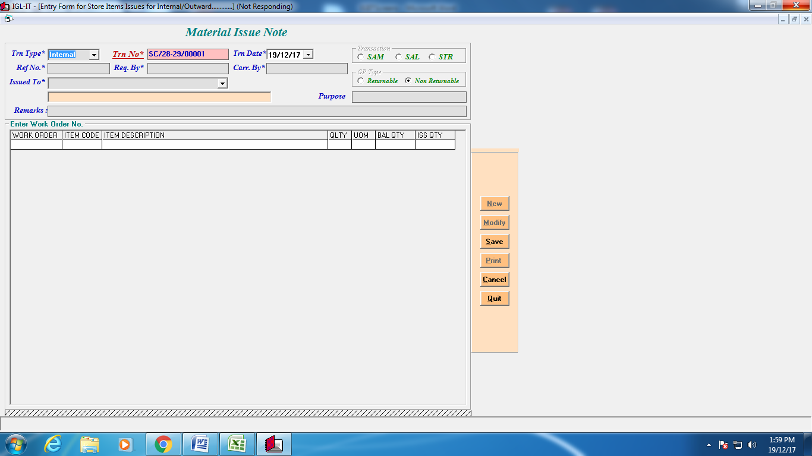

**WO-WO Transfer**

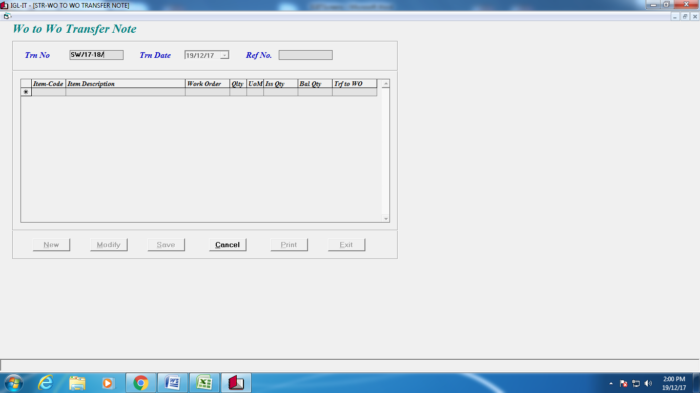

**Non Moving Transfer**

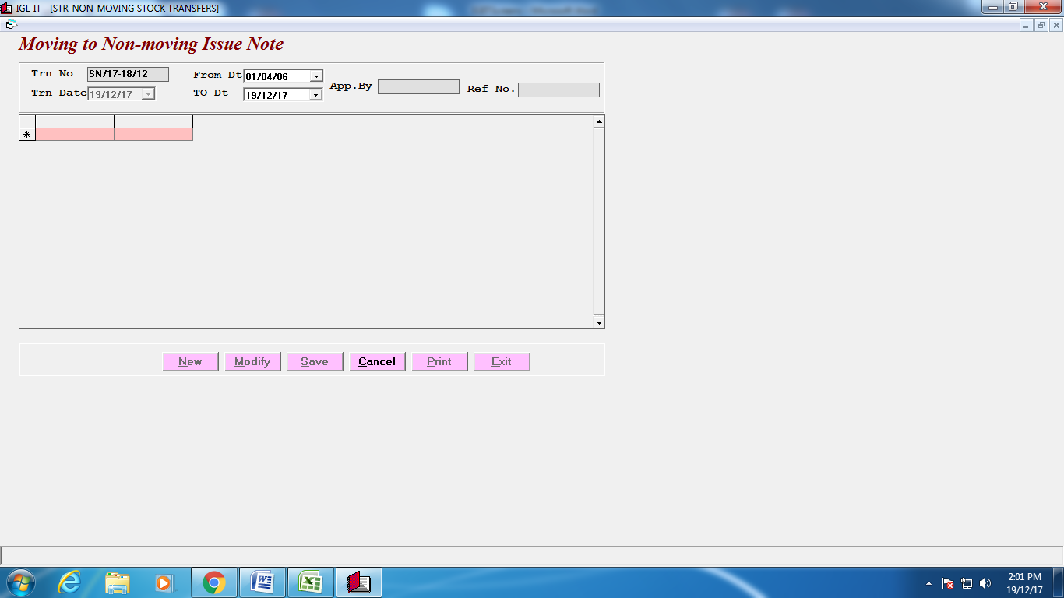

**Trims Gate Pass (Job/Sale/Trf/Ret)**

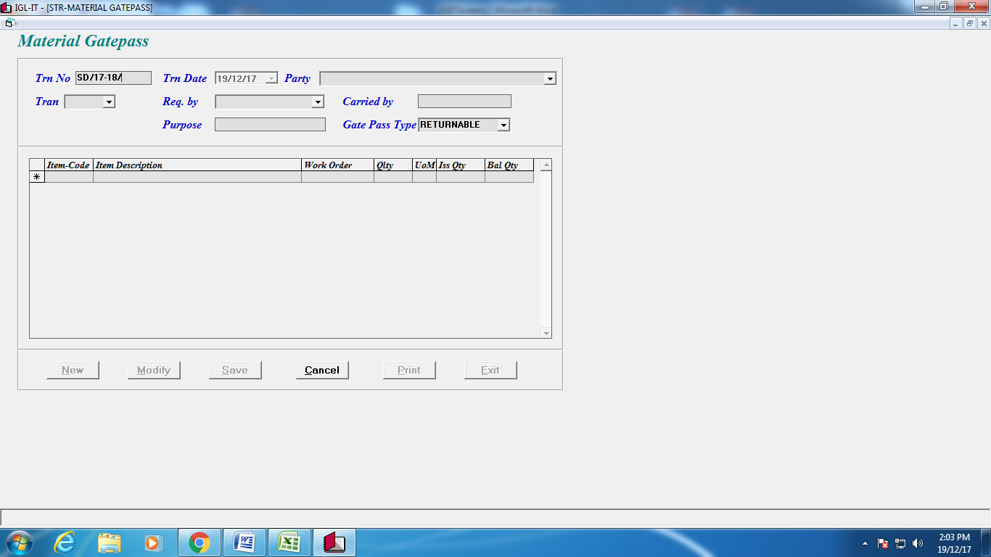

**General Gate Pass**

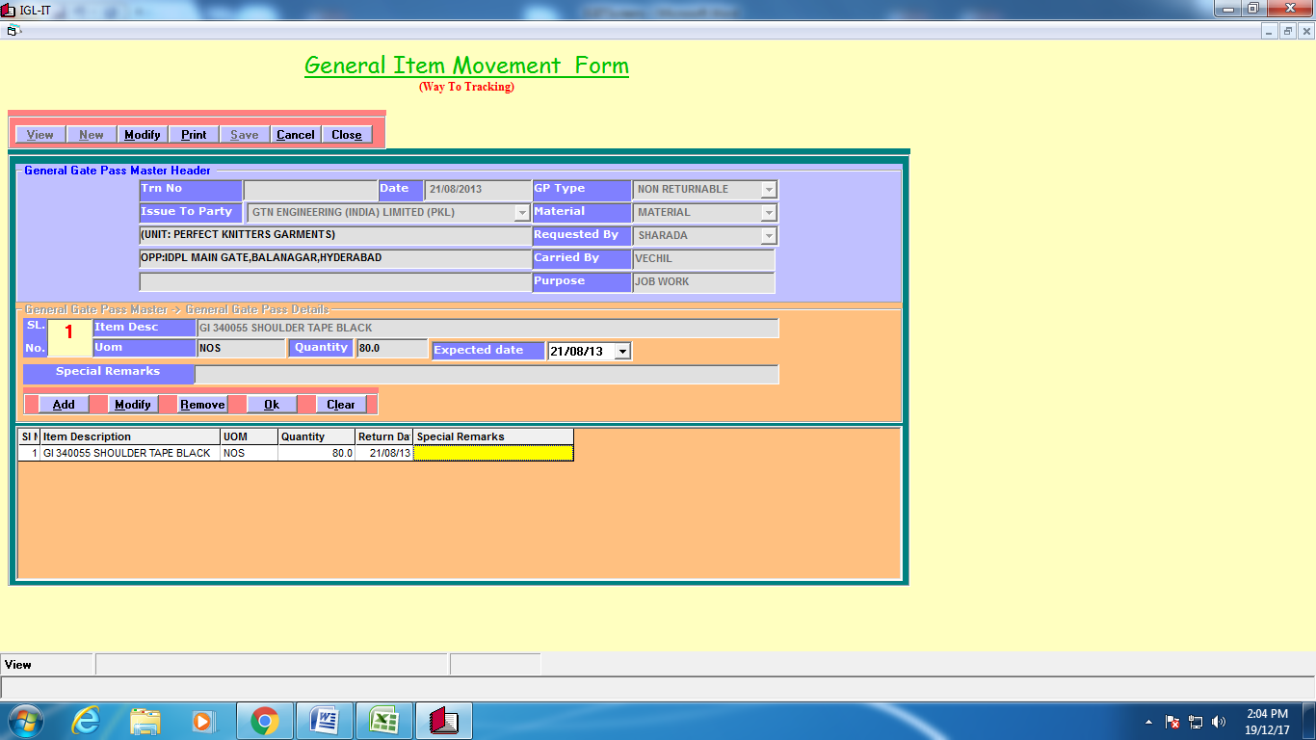

**Reports**

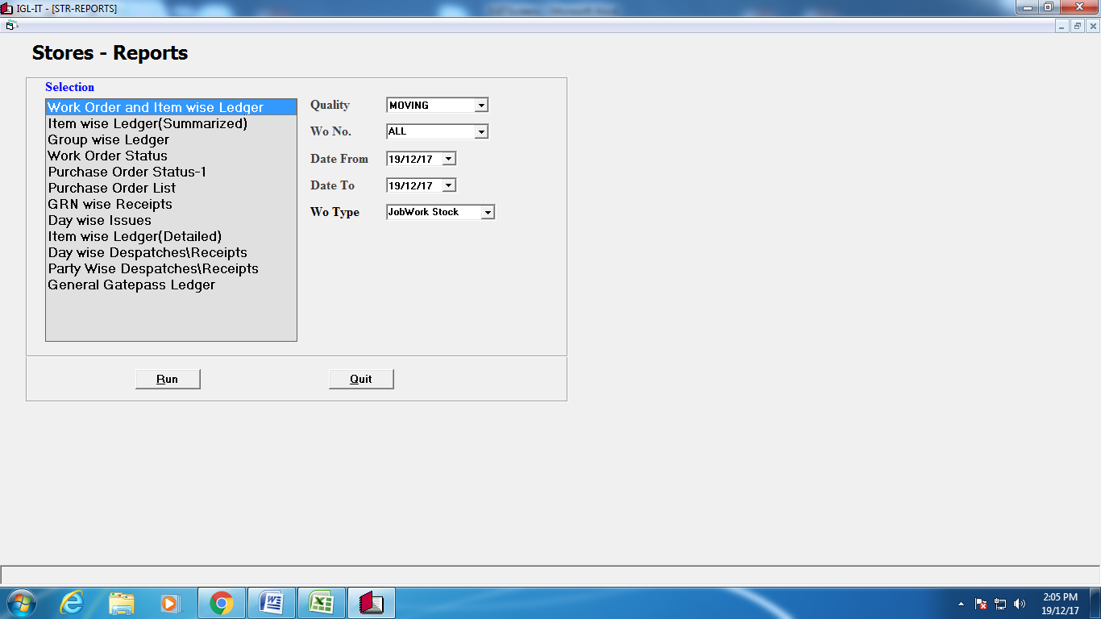

**Financial Accounts**

|  |
| --- |
| Sales Invoice (Demostic/Exp) |
| Jobwork Challan |
| Payment Vouchers |
| Receipt Vouchers |
| Journal Vouchers |
| Debit Notes |
| Credit Notes |
| General Ledger |
| Reports |

Create New From

**Payroll**

|  |
| --- |
| New employee Creation |
| Left emplyees entry |
| Daily Attendance Download |
| Leaves Entry |
| Swipe Miss entry |
| Daily Reports |
| Monthly Reports |
| Monthly Attendance Creation |